**SQL (Structured Query Language)**

SQL stands for Structured Query Language, and it's a programming language that allows users to interact with relational databases. SQL statements can be used to store, update, remove, search, and retrieve information from a database, as well as maintain and optimize its performance.

**There are some major advantages to using traditional relational databases, which we interact with using SQL. The five most apparent are:**

* SQL is easy to understand.
* Traditional databases allow us to access data directly.
* Traditional databases allow us to audit and replicate our data.
* SQL is a great tool for analyzing multiple tables at once.
* SQL allows you to analyze more complex questions than dashboard tools like Google Analytics.

**Types of Databases**

**SQL Databases:**

There are many different types of SQL databases designed for different purposes. In this course we will use PostgreSQL (opens in a new tab) within the classroom, which is a popular open-source database with a very complete library of analytical functions.

Some of the most popular databases include:

* MySQL
* Access
* Oracle
* Microsoft SQL Server
* Postgres

You can also write SQL within other programming frameworks like Python, Scala, and Hadoop.

**The key to SQL is understanding statements. A few statements include:**

1. CREATE TABLE is a statement that creates a new table in a database.
2. DROP TABLE is a statement that removes a table in a database.
3. SELECT allows you to read data and display it. This is called a query.

**Here you were introduced to the SQL command that will be used in every query you write: SELECT ... FROM ....**

1. SELECT indicates which column(s) you want to be given the data for.
2. FROM specifies from which table(s) you want to select the columns. Notice the columns need to exist in this table.

If you want to be provided with the data from all columns in the table, you use "*", like so:

**SELECT * FROM orders**

***Note that using SELECT does not create a new table with these columns in the database, it just provides the data to you as the results, or output, of this command.***

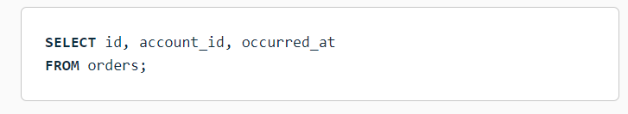

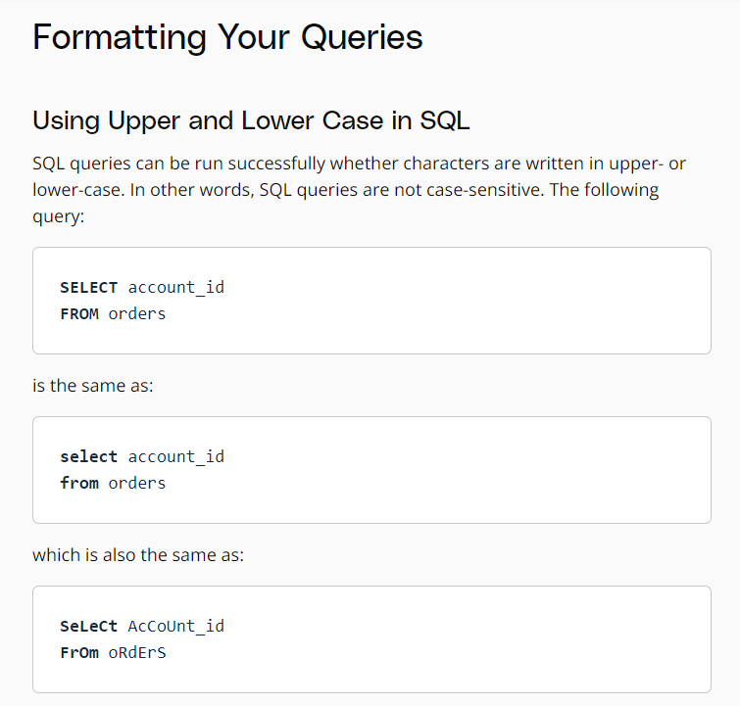

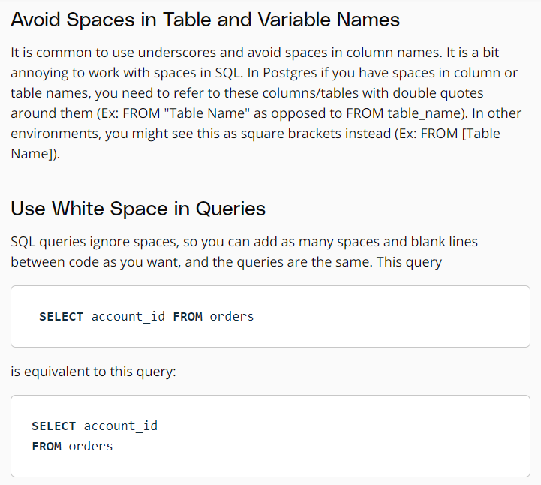

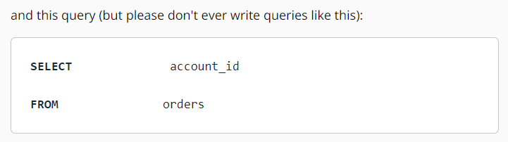

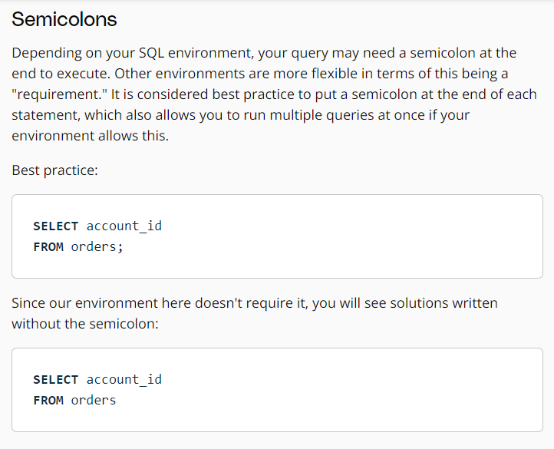

**LIMIT:**

The LIMIT statement is useful when you want to see just the first few rows of a table. This can be much faster for loading than if we load the entire dataset.

The LIMIT command is always the very last part of a query. An example of showing just the first 10 rows of the orders table with all of the columns might look like the following:

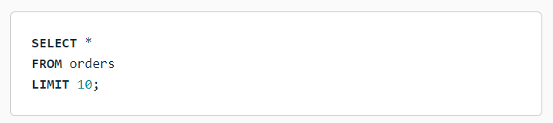

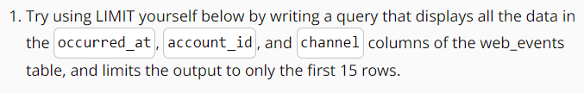

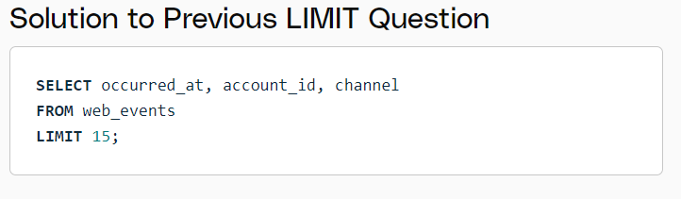

**ORDER BY:**

The ***ORDER BY*** statement allows us to sort our results using the data in any column. If you are familiar with Excel or Google Sheets, using ORDER BY is similar to sorting a sheet using a column. A key difference, however, is that using ORDER BY in a SQL query only has temporary effects, for the results of that query, unlike sorting a sheet by column in Excel or Sheets.

In other words, when you use ORDER BY in a SQL query, your output will be sorted that way, but then the next query you run will encounter the unsorted data again. It's important to keep in mind that this is different than using common spreadsheet software, where sorting the spreadsheet by column actually alters the data in that sheet until you undo or change that sorting. This highlights the meaning and function of a SQL "query."

The ORDER BY statement always comes in a query after the SELECT and FROM statements, but before the LIMIT statement. If you are using the LIMIT statement, it will always appear last. As you learn additional commands, the order of these statements will matter more.

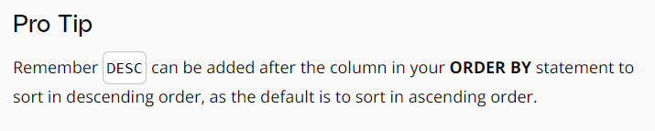

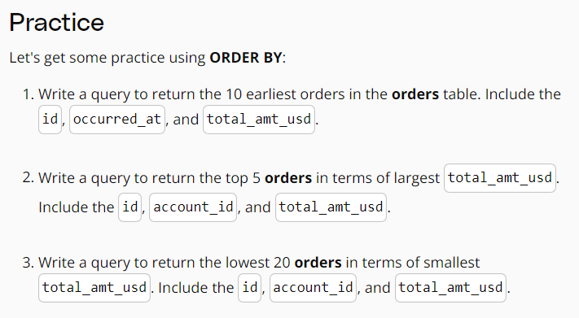

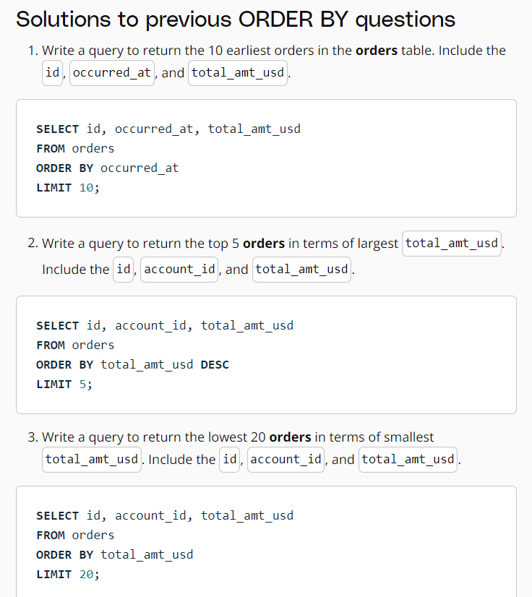

When you provide a list of columns in an ORDER BY command, the sorting occurs using the leftmost column in your list first, then the next column from the left, and so on. We still have the ability to flip the way we order using DESC.

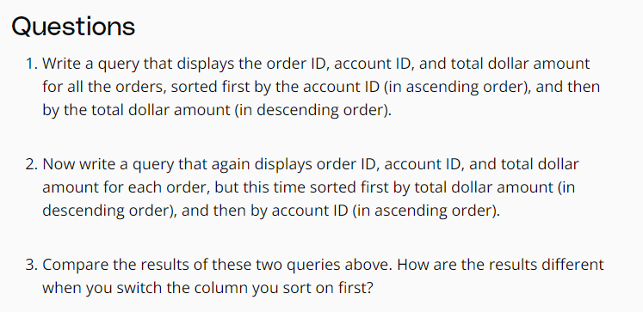

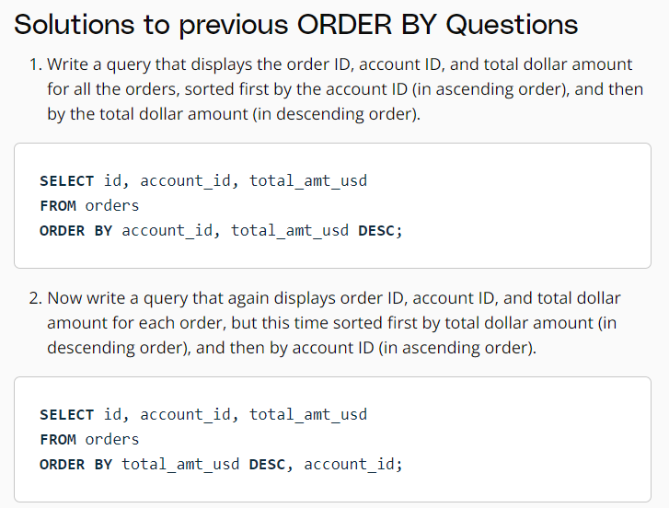

**WHERE:**

Using the WHERE statement, we can display subsets of tables based on conditions that must be met. You can also think of the WHERE command as filtering the data.

This video above shows how this can be used, and in the upcoming concepts, you will learn some common operators that are useful with the WHERE' statement.

Common symbols used in WHERE statements include:

* (greater than)
* < (less than)
* >= (greater than or equal to)
* <= (less than or equal to)
* = (equal to)
* != (not equal to)

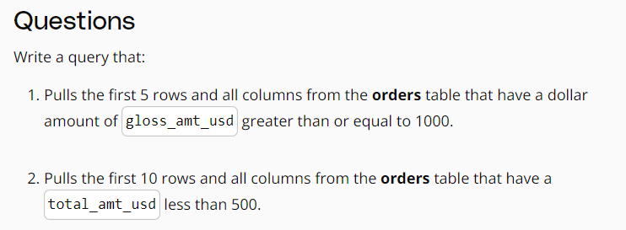

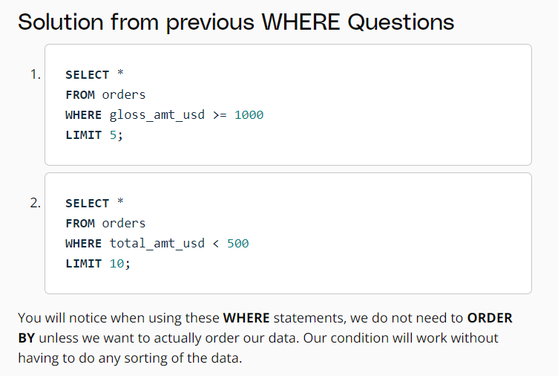

The WHERE statement can also be used with non-numeric data. We can use the = and != operators here. You need to be sure to use single quotes (just be careful if you have quotes in the original text) with the text data, not double quotes.

Commonly when we are using WHERE with non-numeric data fields, we use the LIKE, NOT, or IN operators.

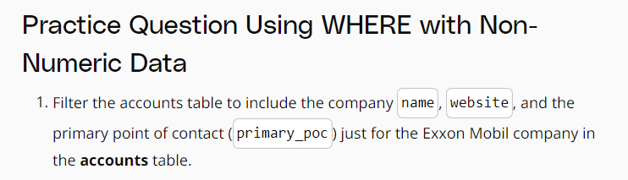

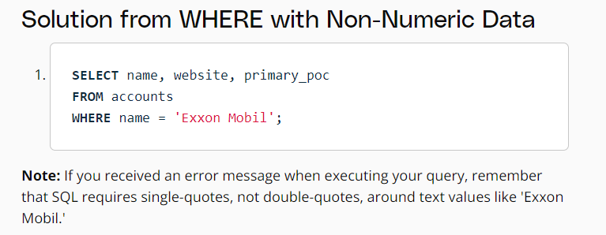

**ARITHMETIC OPERATOR:**

**Derived Columns**

Creating a new column that is a combination of existing columns is known as a derived column (or "calculated" or "computed" column). Usually you want to give a name, or "alias," to your new column using the AS keyword.

This derived column, and its alias, are generally only temporary, existing just for the duration of your query. The next time you run a query and access this table, the new column will not be there.

If you are deriving the new column from existing columns using a mathematical expression, then these familiar mathematical operators will be useful:

* *(Multiplication)
* + (Addition)
* - (Subtraction)
* / (Division)

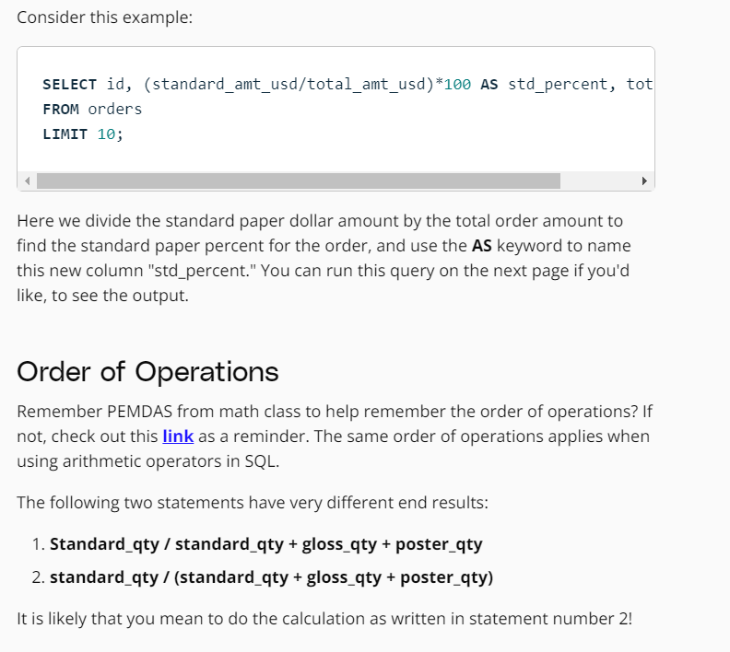

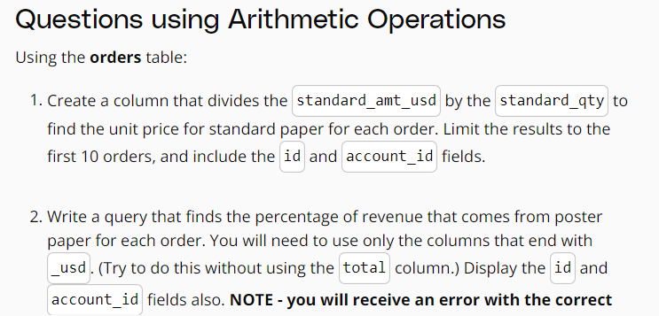

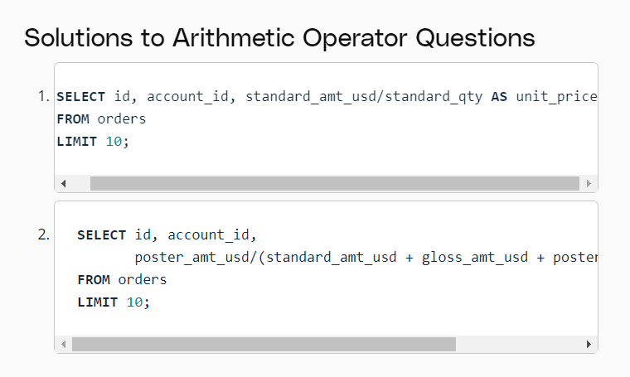

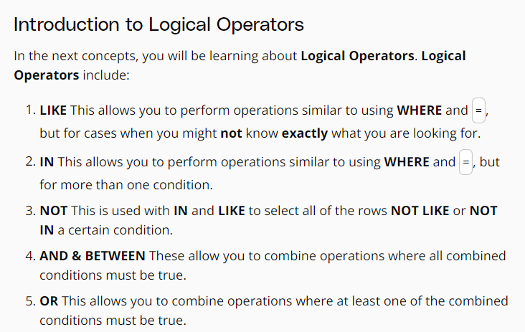

**LIKE:**

The LIKE operator is extremely useful for working with text. You will use LIKE within a WHERE clause. The LIKE operator is frequently used with %. The % tells us that we might want any number of characters leading up to a particular set of characters or following a certain set of characters, as we saw with the google syntax above. Remember you will need to use single quotes for the text you pass to the LIKE operator, because of this lower and uppercase letter are not the same within the string. Searching for 'T' is not the same as searching for 't'. In other SQL environments (outside the classroom), you can use either single or double quotes.

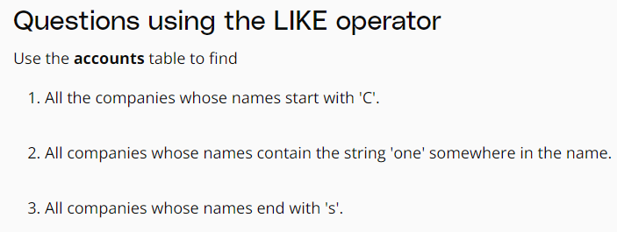

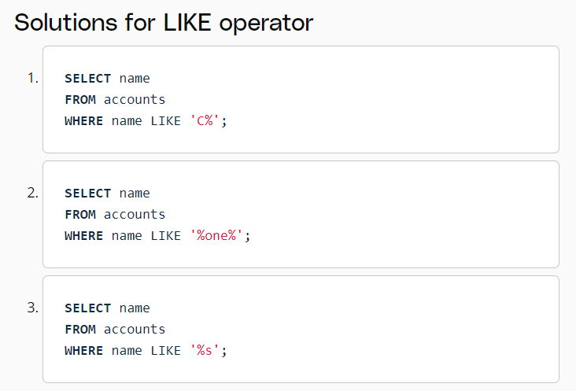

**IN:**

The IN operator is useful for working with both numeric and text columns. This operator allows you to use an =, but for more than one item of that particular column. We can check one, two or many column values for which we want to pull data, but all within the same query. In the upcoming concepts, you will see the OR operator that would also allow us to perform these tasks, but the IN operator is a cleaner way to write these queries.

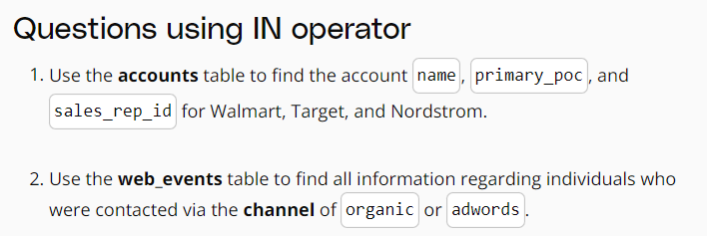

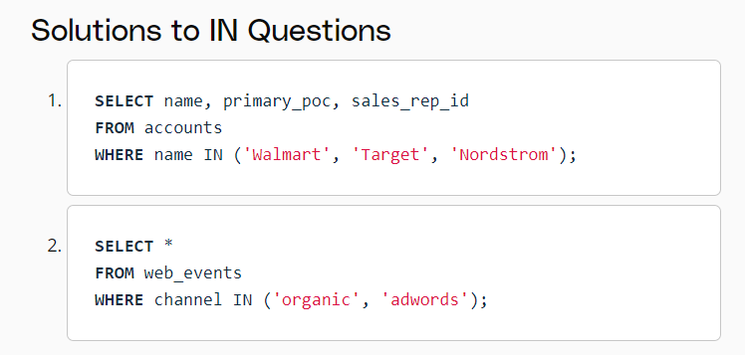

**NOT:**

The NOT operator is an extremely useful operator for working with the previous two operators we introduced: IN and LIKE. By specifying NOT LIKE or NOT IN, we can grab all of the rows that do not meet a particular criteria.

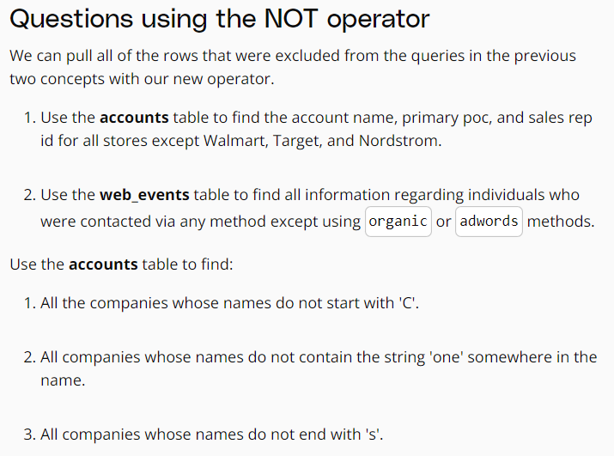

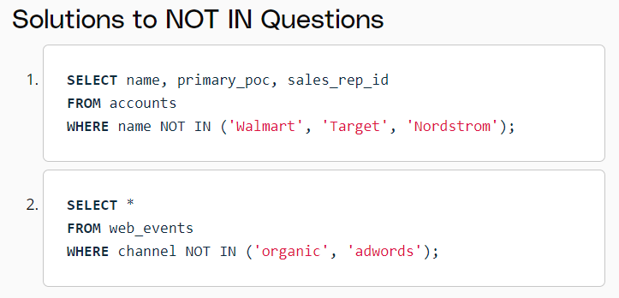

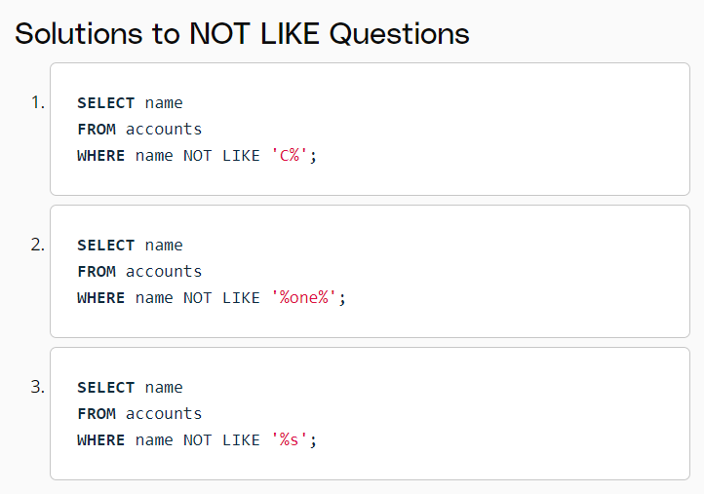

**AND:**

The AND operator is used within a WHERE statement to consider more than one logical clause at a time. Each time you link a new statement with an AND, you will need to specify the column you are interested in looking at. You may link as many statements as you would like to consider at the same time. This operator works with all of the operations we have seen so far including arithmetic operators (+, *, -, /).* LIKE*,* IN*, and* NOT logic can also be linked together using the AND* operator.

**BETWEEN Operator:**

Sometimes we can make a cleaner statement using BETWEEN than we can using AND. Particularly this is true when we are using the same column for different parts of our AND statement. In the previous video, we probably should have used BETWEEN.

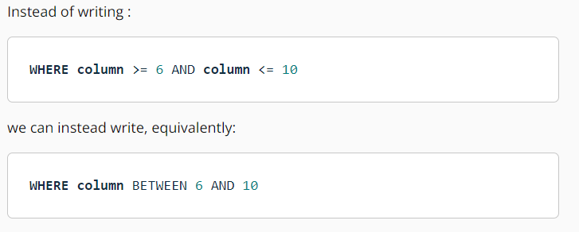

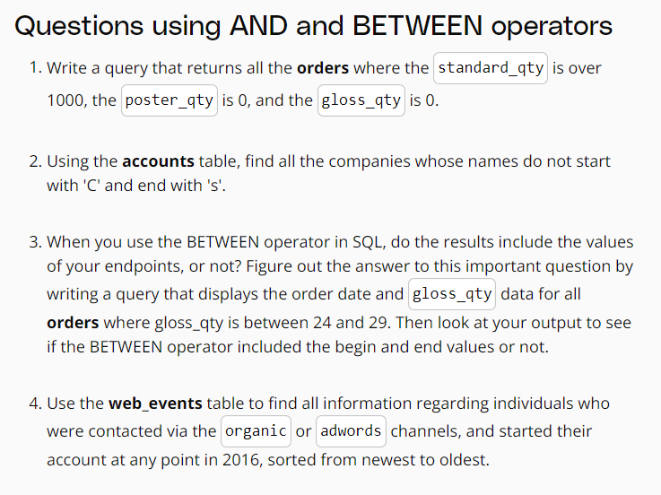

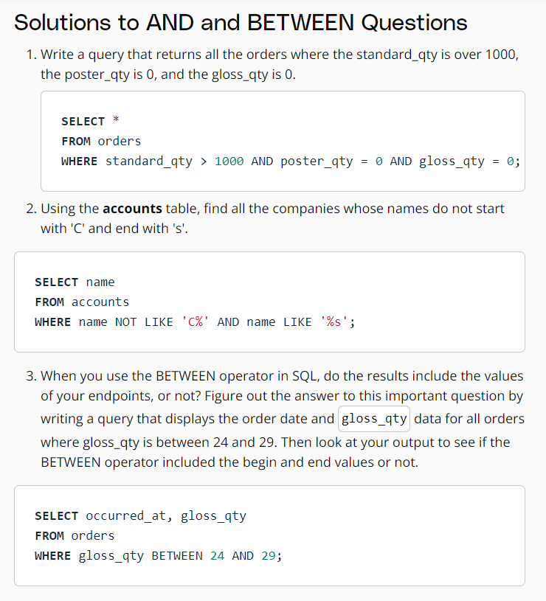

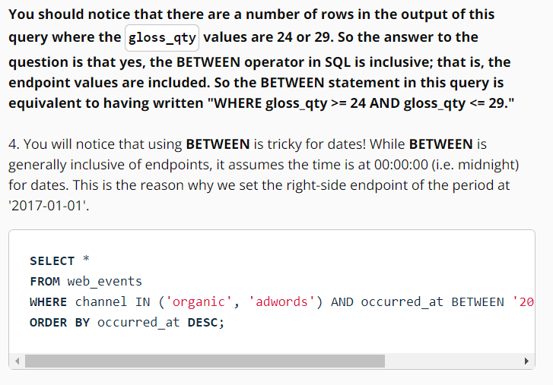

**OR:**

Similar to the AND operator, the OR operator can combine multiple statements. Each time you link a new statement with an OR, you will need to specify the column you are interested in looking at. You may link as many statements as you would like to consider at the same time. This operator works with all of the operations we have seen so far including arithmetic operators (+, *, -, /),* LIKE*,* IN*,* NOT*,* AND*, and* BETWEEN logic can all be linked together using the OR* operator.

When combining multiple of these operations, we frequently might need to use parentheses to assure that logic we want to perform is being executed correctly. The video below shows an example of one of these situations.

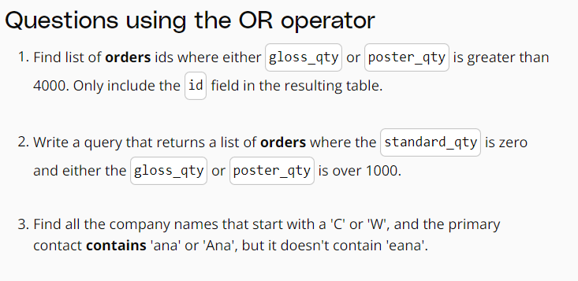

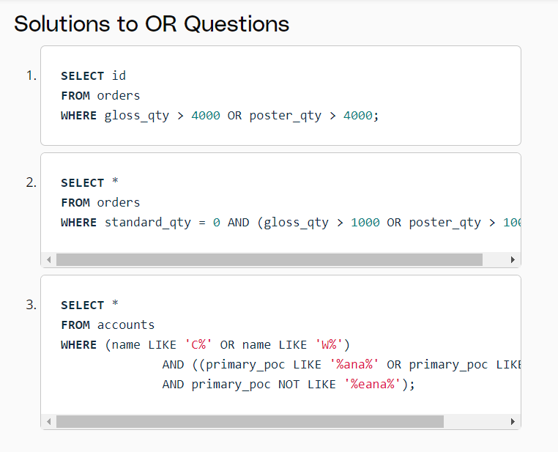

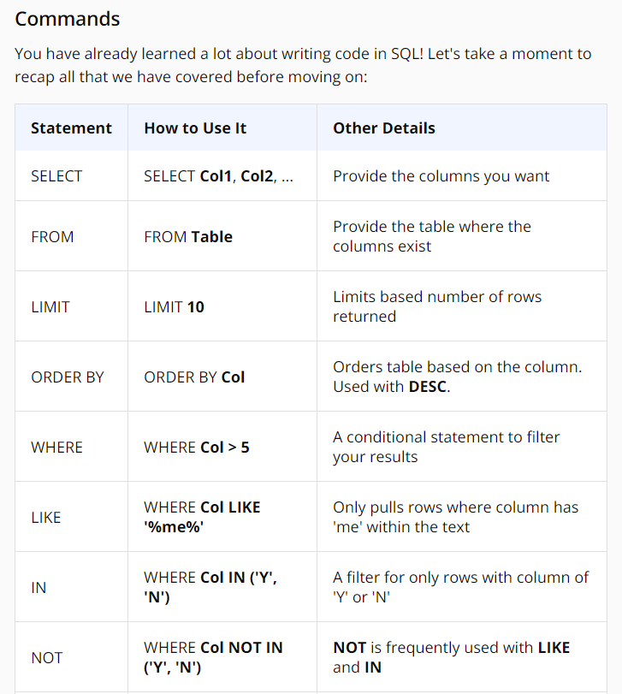

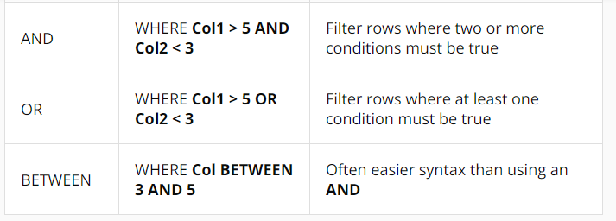

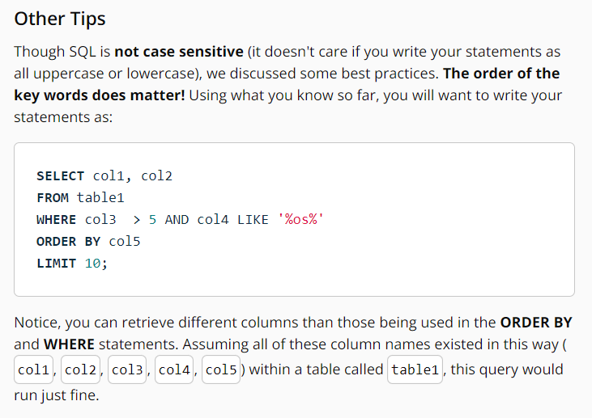

**SQL JOINS:**

The whole purpose of JOIN statements is to allow us to pull data from more than one table at a time.

Again - JOINs are useful for allowing us to pull data from multiple tables. This is both simple and powerful all at the same time.

With the addition of the JOIN statement to our toolkit, we will also be adding the ON statement.

We use ON clause to specify a JOIN condition which is a logical statement to combine the table in FROM and JOIN statements.

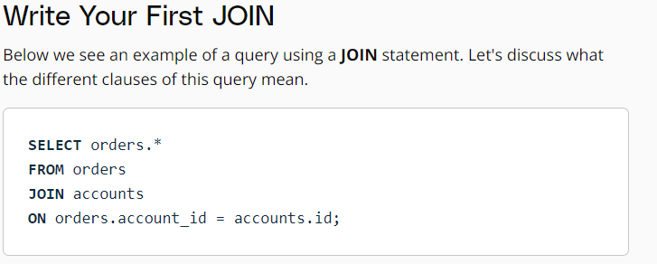

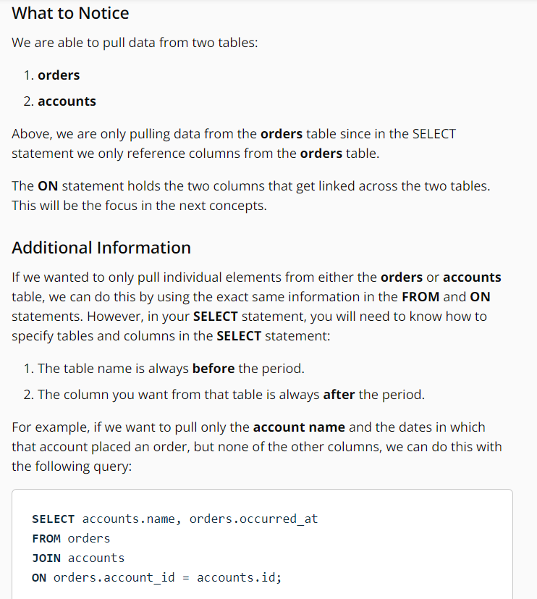

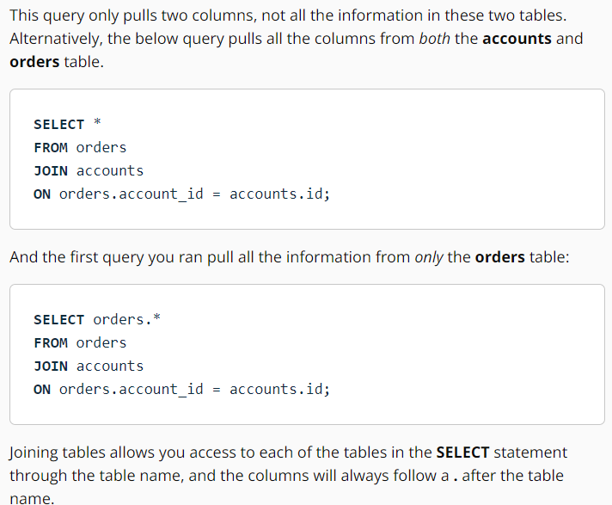

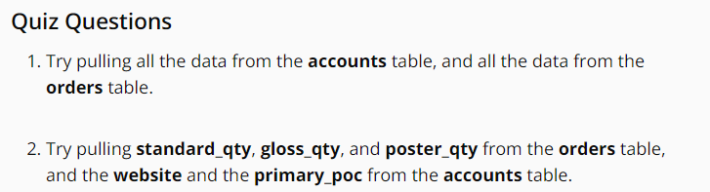

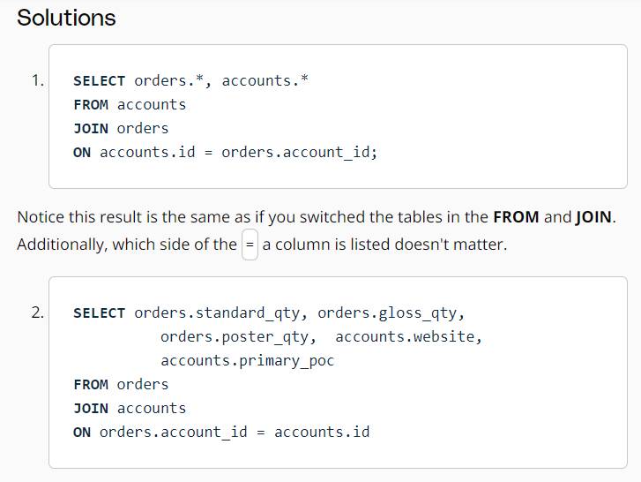

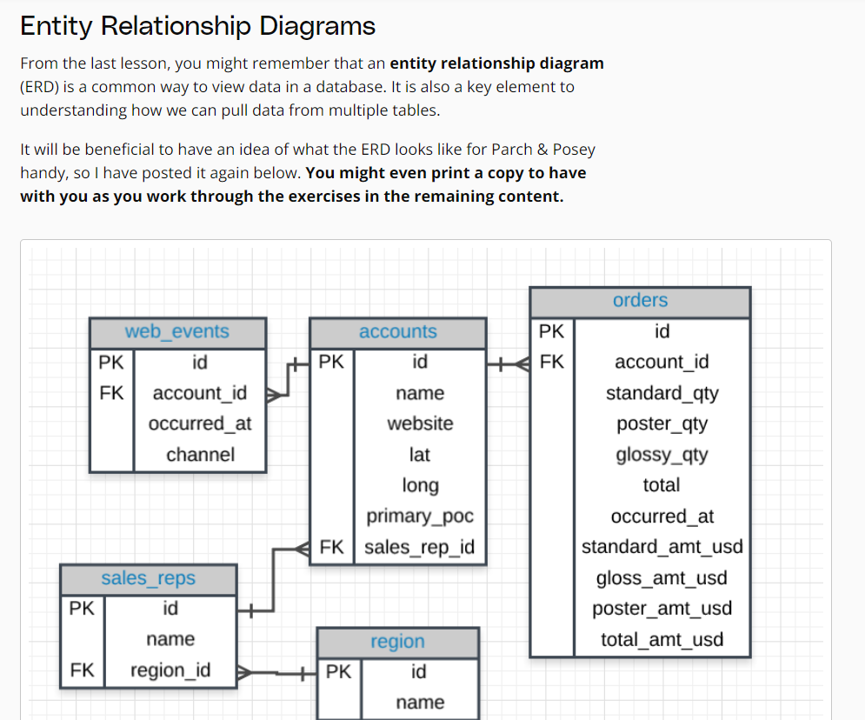

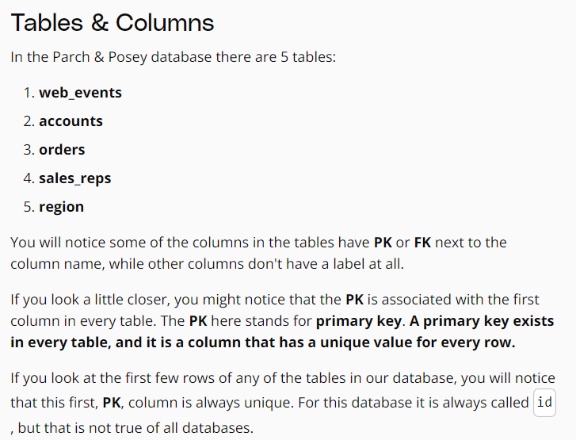

**Keys:**

**Primary Key (PK)**

A primary key is a unique column in a particular table. This is the first column in each of our tables. Here, those columns are all called id, but that doesn't necessarily have to be the name. It is common that the primary key is the first column in our tables in most databases.

**Foreign Key (FK)**

A foreign key is a column in one table that is a primary key in a different table. We can see in the Parch & Posey ERD that the foreign keys are:

* region_id
* account_id
* sales_rep_id

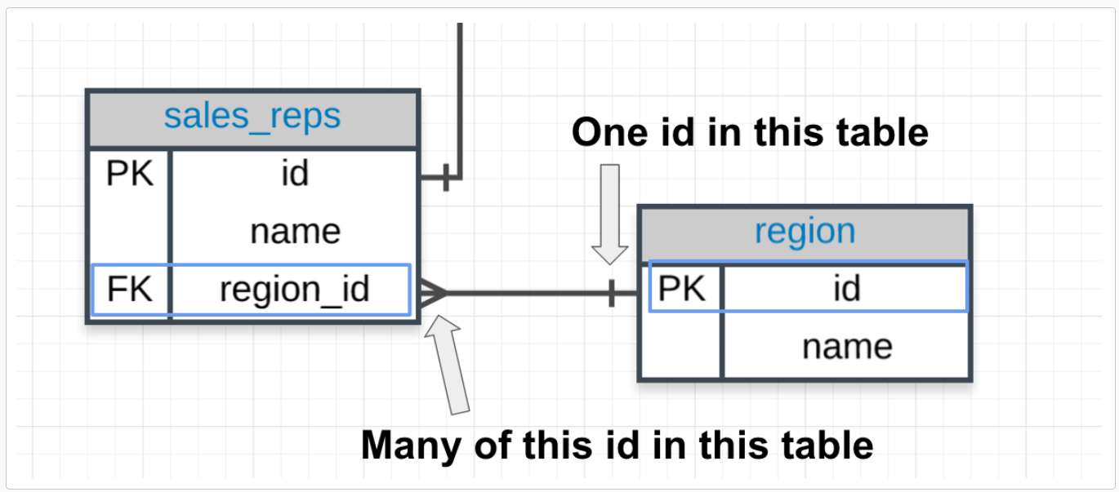

**Primary - Foreign Key Link**

In the above image you can see that:

1. The region_id is the foreign key.
2. The region_id is linked to id - this is the primary-foreign key link that connects these two tables.
3. The crow's foot shows that the FK can actually appear in many rows in the sales_reps table.

While the single line is telling us that the PK shows that id appears only once per row in this table.

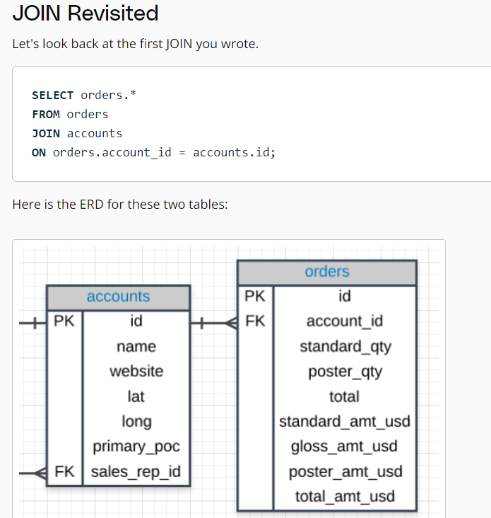

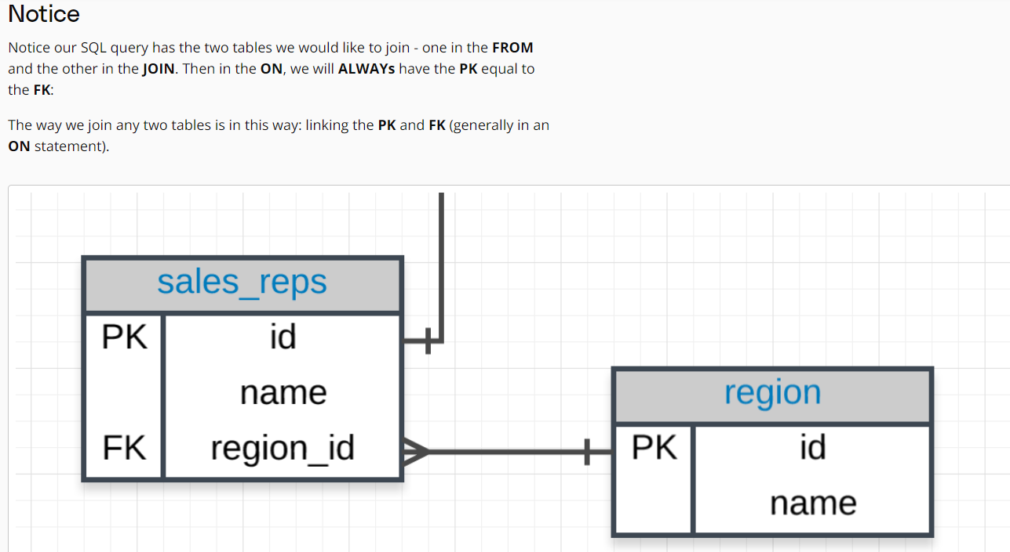

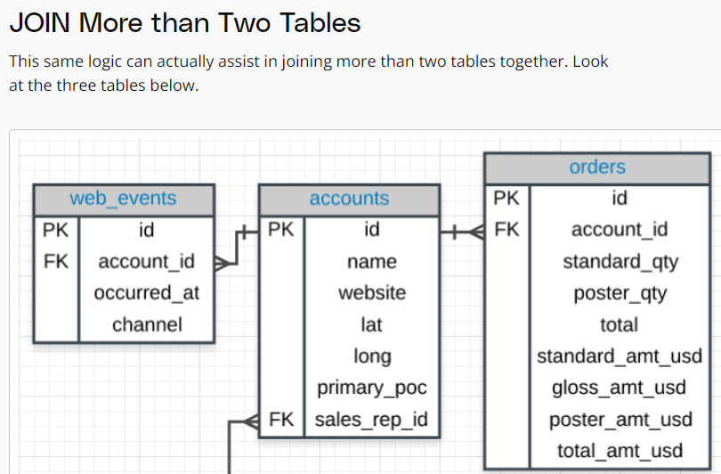

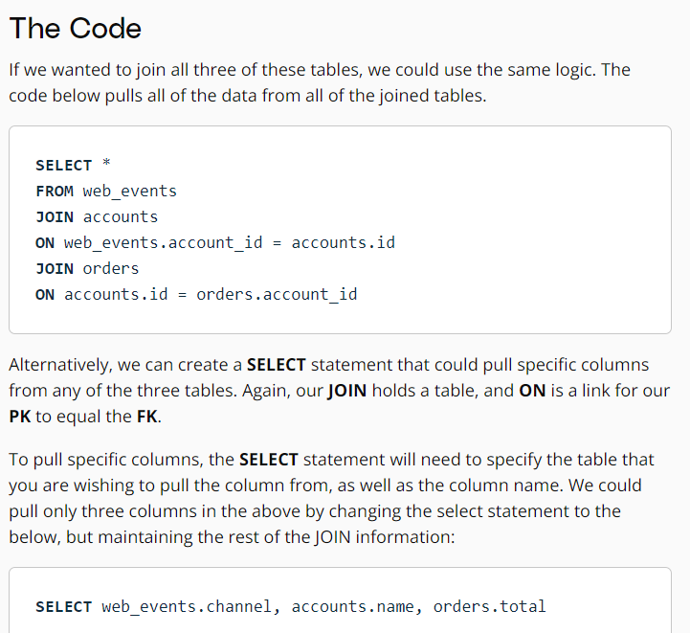

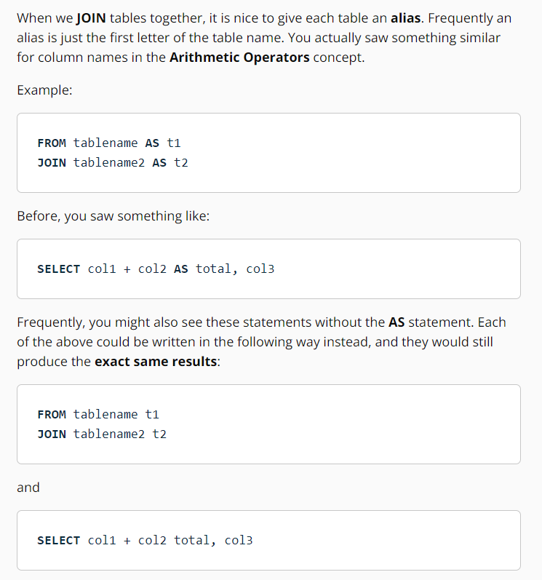

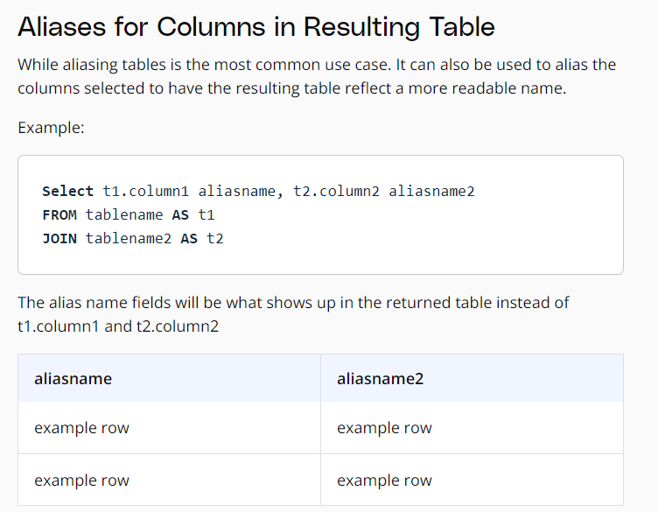

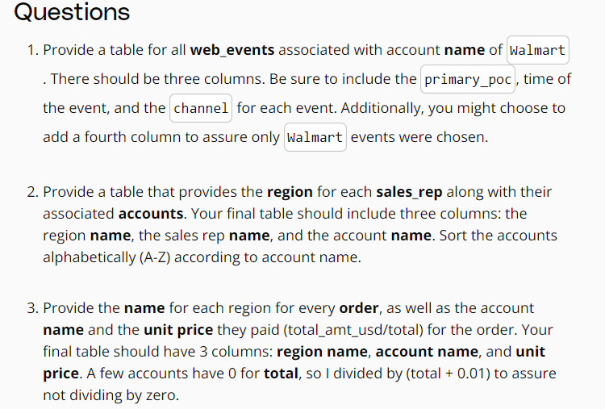

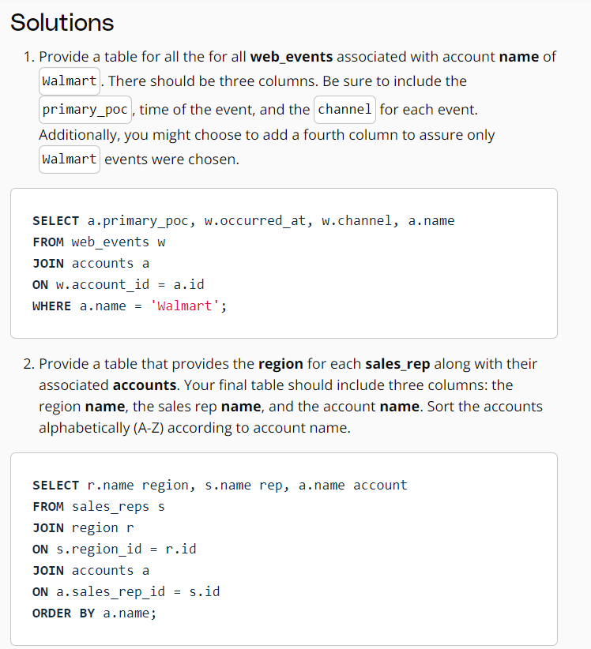

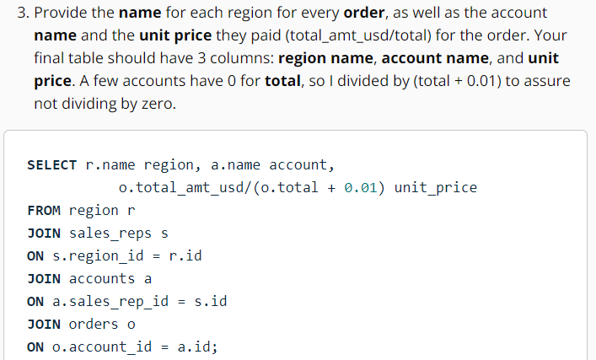

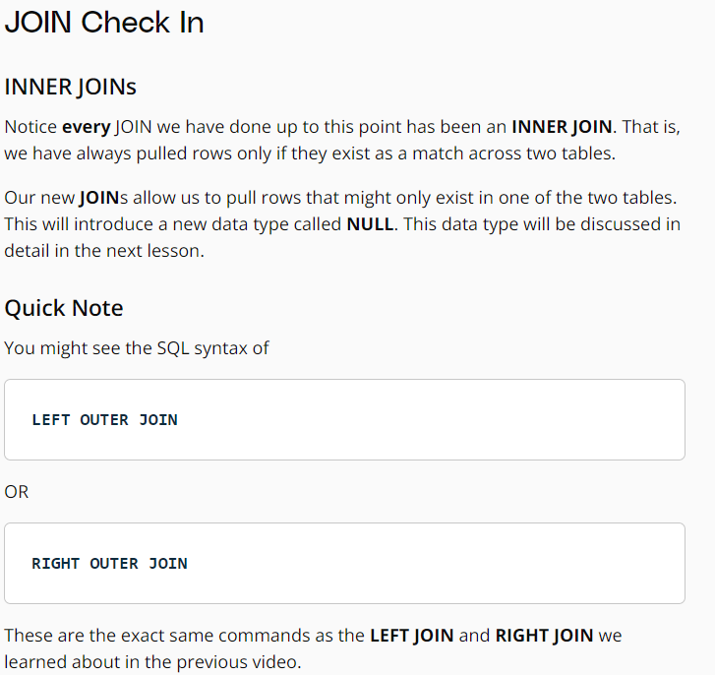

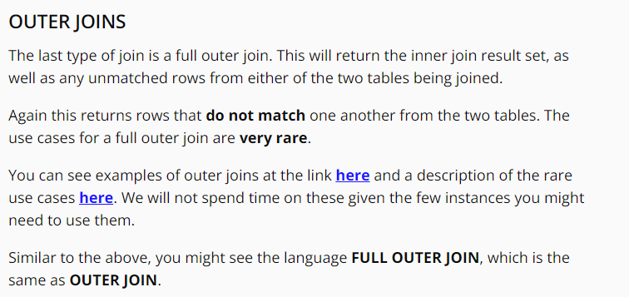

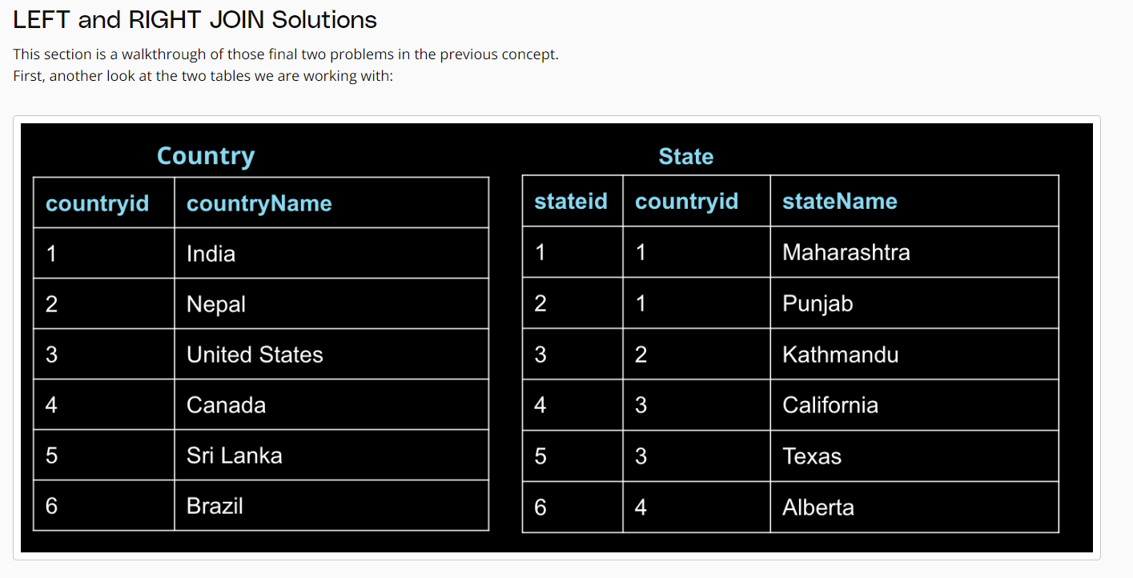

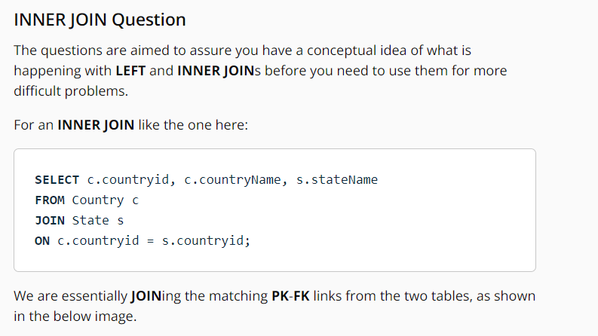

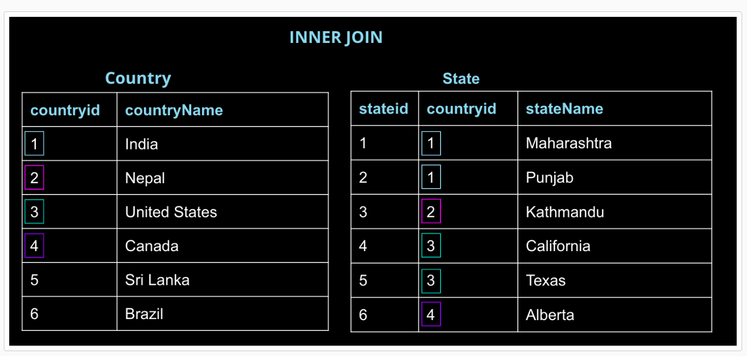

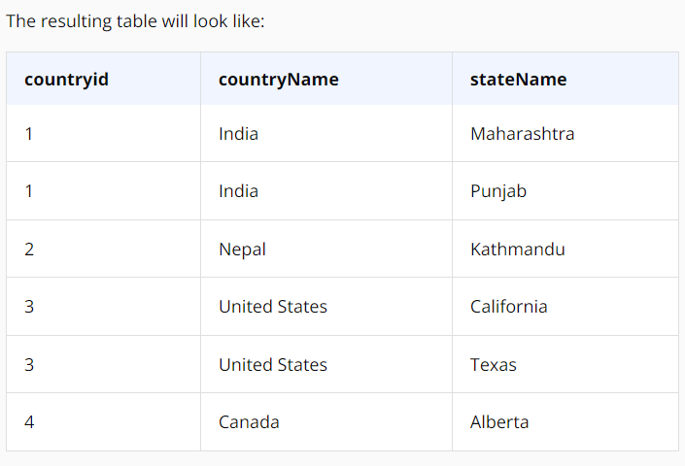

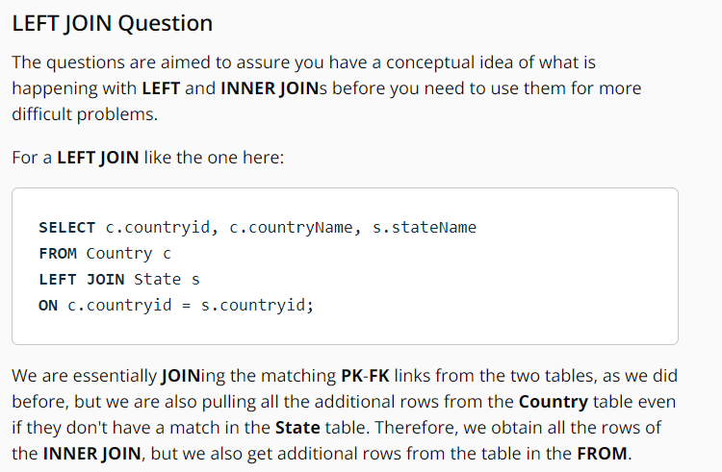

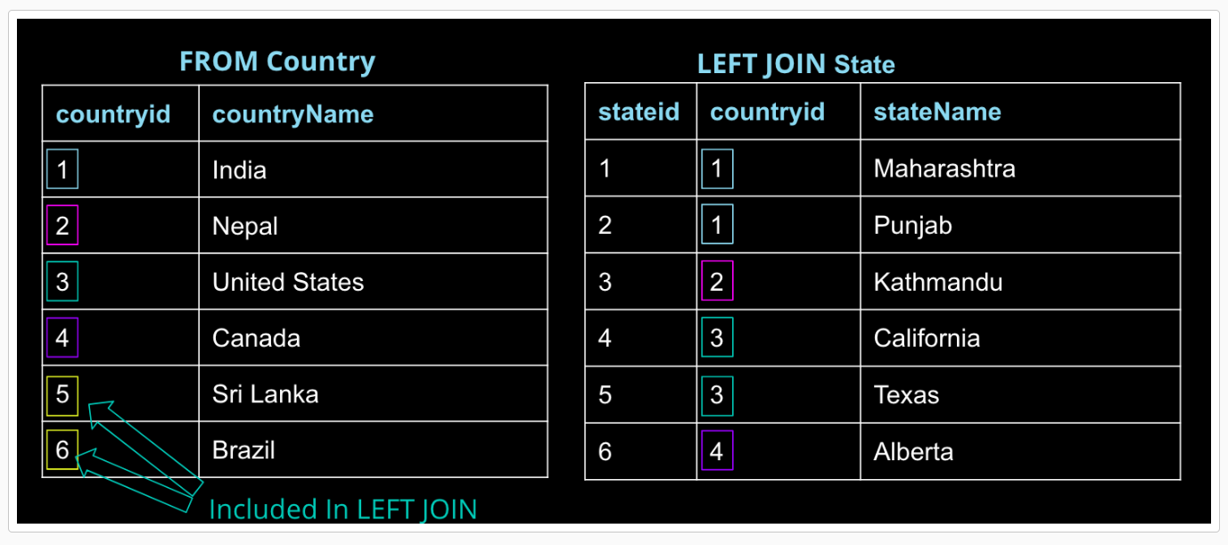

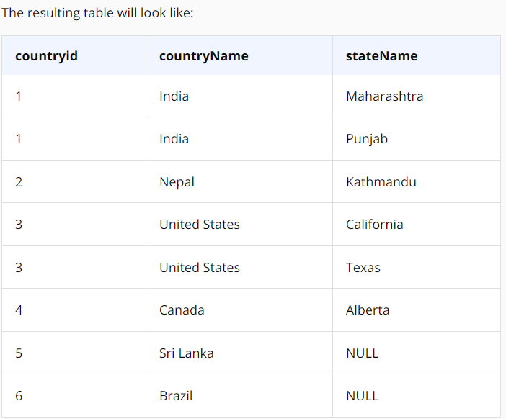

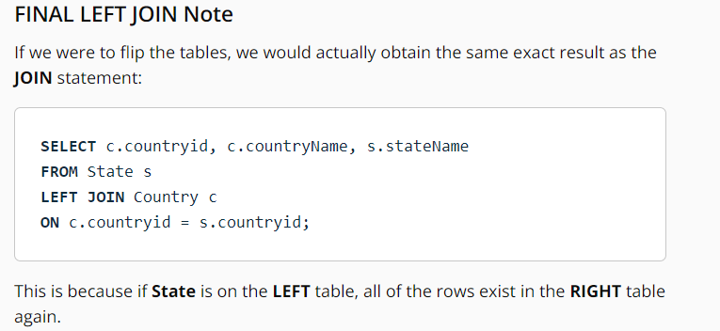

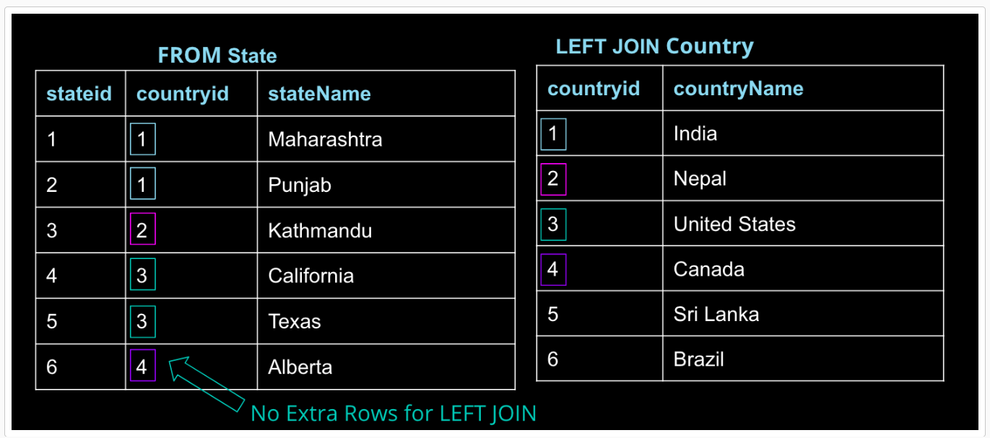

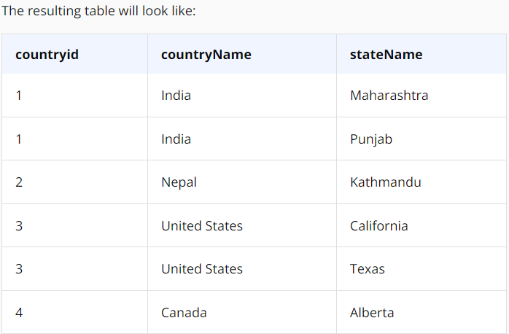

A simple rule to remember this is that, when the database executes this query, it executes the join and everything in the ON clause first. Think of this as building the new result set. That result set is then filtered using the WHERE clause.

The fact that this example is a left join is important. Because inner joins only return the rows for which the two tables match, moving this filter to the ON clause of an inner join will produce the same result as keeping it in the WHERE clause.

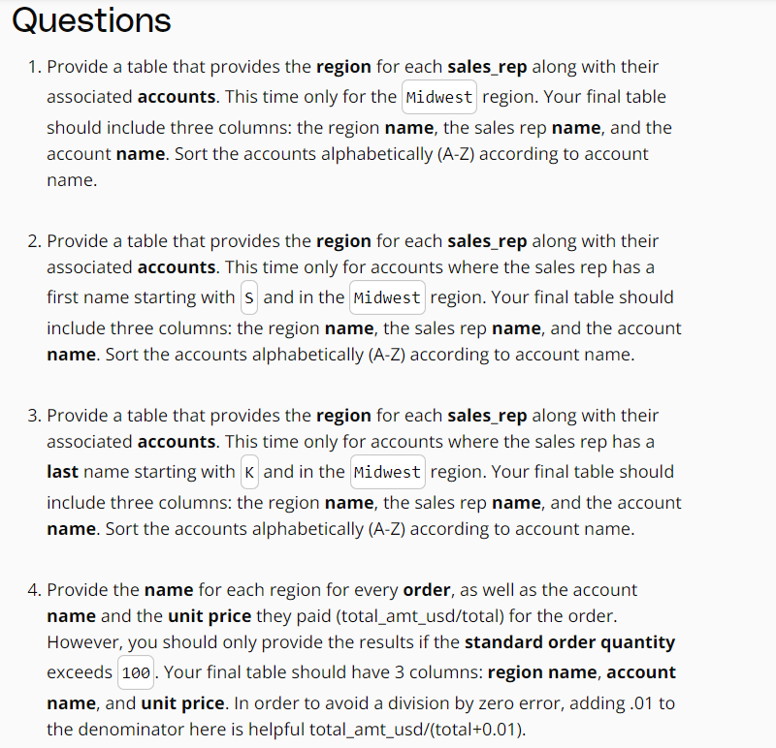

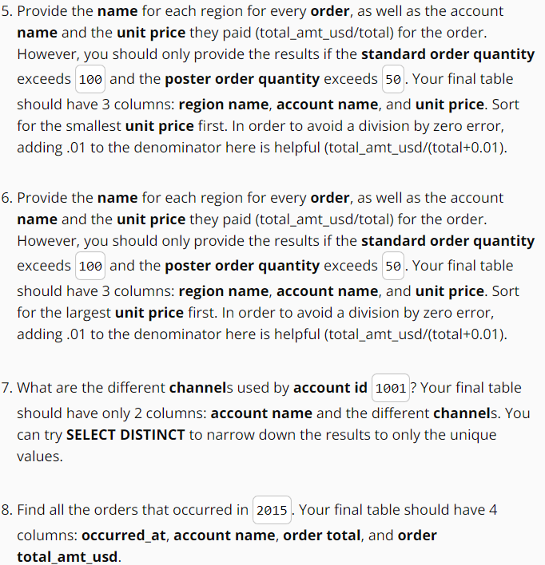

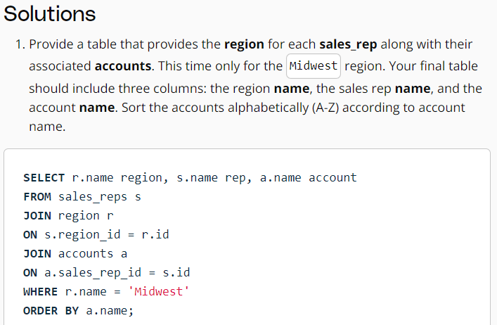

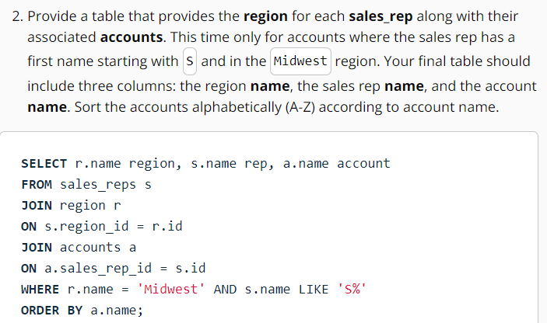

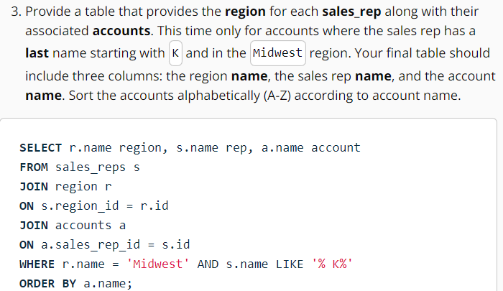

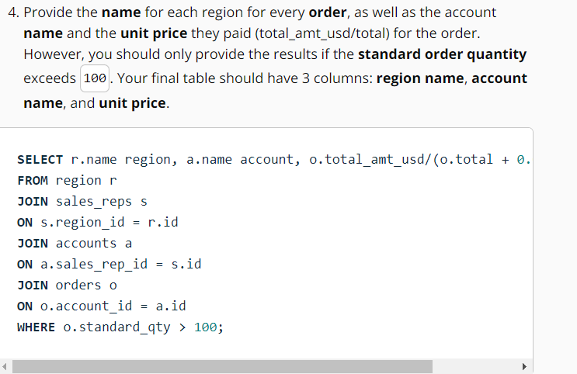

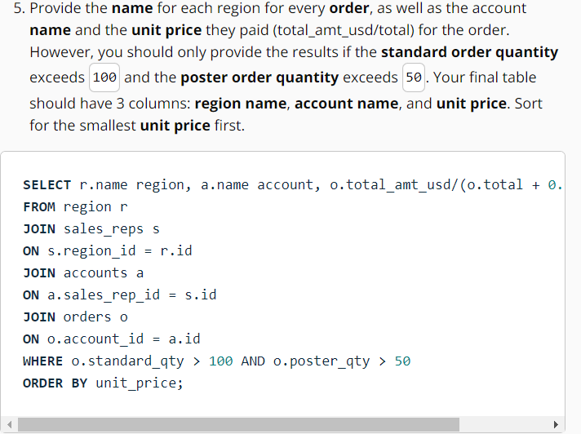

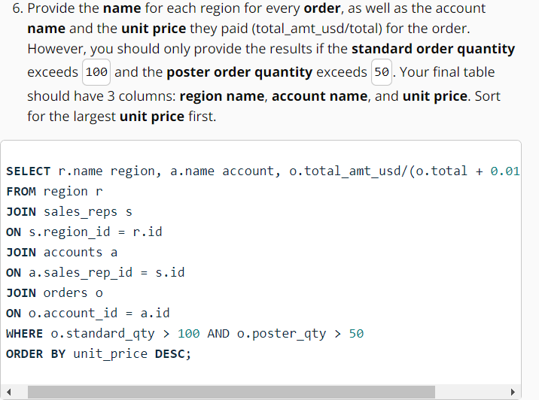

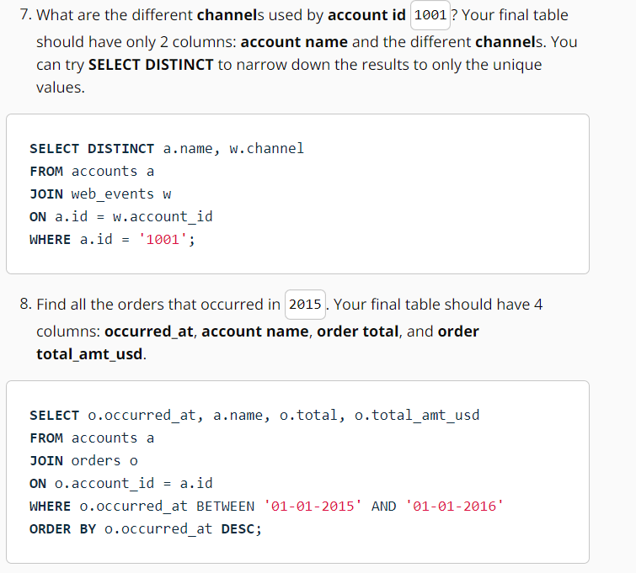

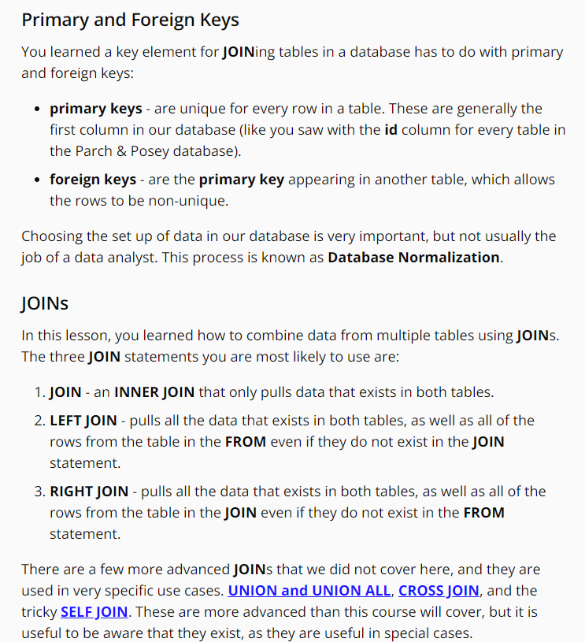

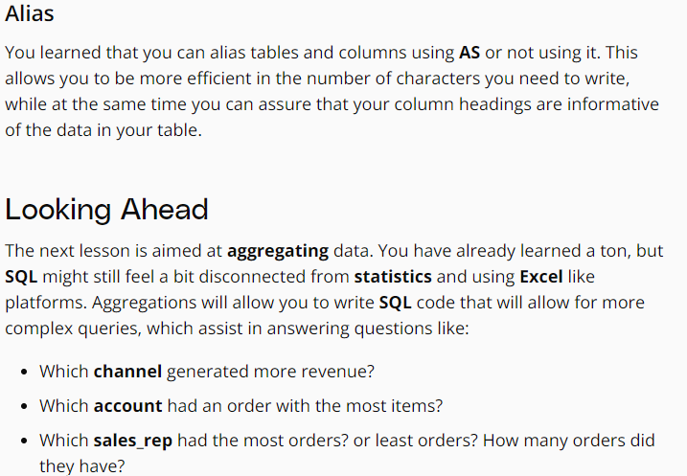

**Introduction to Aggregation**

**Null:**  
NULLs are a datatype that specifies where no data exists in SQL. They are often ignored in our aggregation functions, which you will get a first look at in the next concept using COUNT.

Notice that NULLs are different than a zero - they are cells where data does not exist.

When identifying NULLs in a WHERE clause, we write IS NULL or IS NOT NULL. We don't use =, because NULL isn't considered a value in SQL. Rather, it is a property of the data.

**NULLs - Expert Tip**

There are two common ways in which you are likely to encounter NULLs:

* NULLs frequently occur when performing a LEFT or RIGHT JOIN. You saw in the last lesson - when some rows in the left table of a left join are not matched with rows in the right table, those rows will contain some NULL values in the result set.
* NULLs can also occur from simply missing data in our database.

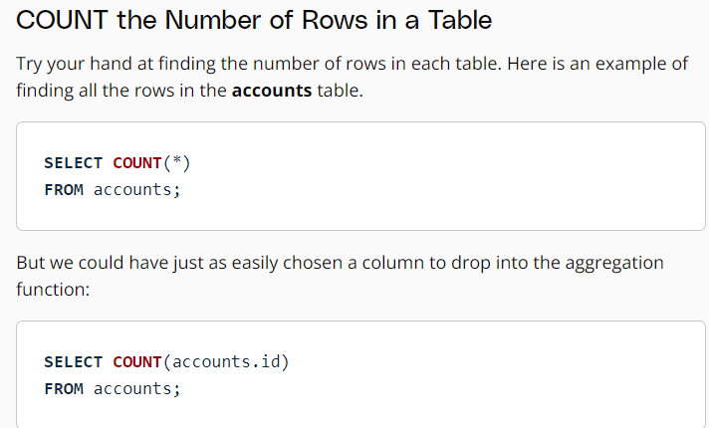

Notice that COUNT does not consider rows that have NULL values. Therefore, this can be useful for quickly identifying which rows have missing data. You will learn GROUP BY in an upcoming concept, and then each of these aggregators will become much more useful.

Unlike COUNT, you can only use SUM on numeric columns. However, SUM will ignore NULL values, as do the other aggregation functions you will see in the upcoming lessons.

**Aggregation Reminder**

An important thing to remember: aggregators only aggregate vertically - the values of a column. If you want to perform a calculation across rows, you would do this with simple arithmetic (opens in a new tab).

We saw this in the first lesson if you need a refresher, but the quiz in the next concept should assure you still remember how to aggregate across rows.

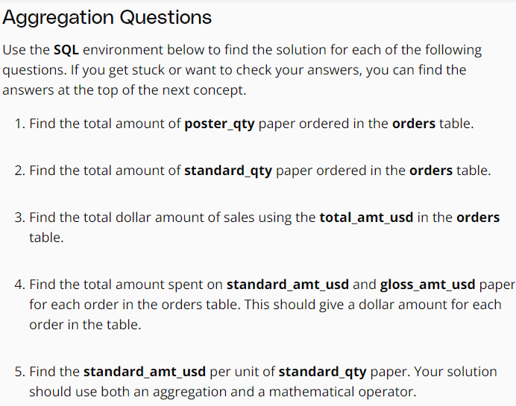

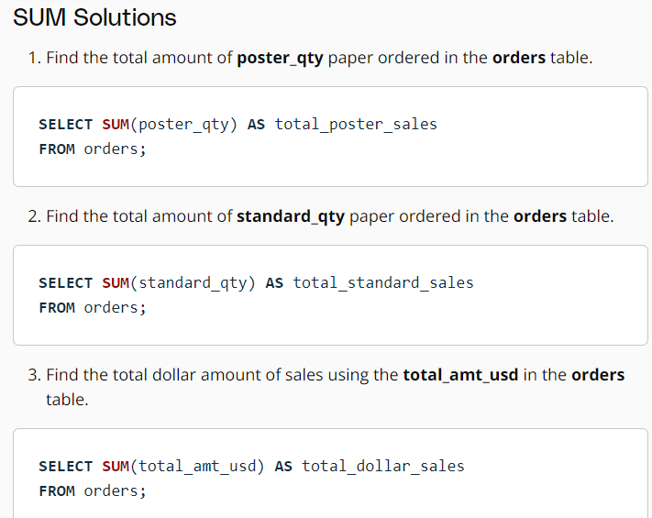

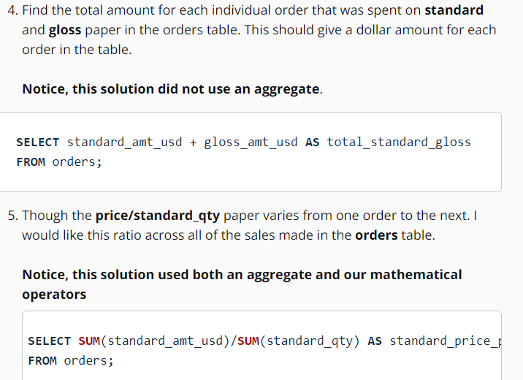

**Expert Tip**

Functionally, MIN and MAX are similar to COUNT in that they can be used on non-numerical columns. Depending on the column type, MIN will return the lowest number, earliest date, or non-numerical value as early in the alphabet as possible. As you might suspect, MAX does the opposite—it returns the highest number, the latest date, or the non-numerical value closest alphabetically to “Z.”

Similar to other software AVG returns the mean of the data - that is the sum of all of the values in the column divided by the number of values in a column. This aggregate function again ignores the NULL values in both the numerator and the denominator.

If you want to count NULLs as zero, you will need to use SUM and COUNT. However, this is probably not a good idea if the NULL values truly just represent unknown values for a cell.

**MEDIAN - Expert Tip**

One quick note that a median might be a more appropriate measure of center for this data, but finding the median happens to be a pretty difficult thing to get using SQL alone — so difficult that finding a median is occasionally asked as an interview question.

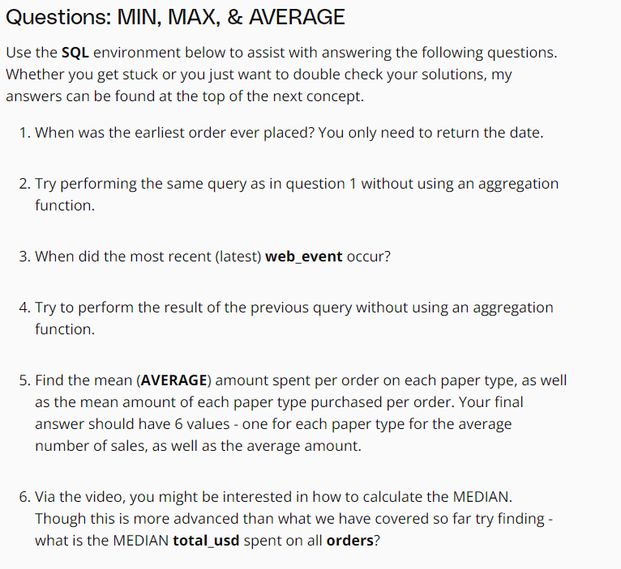

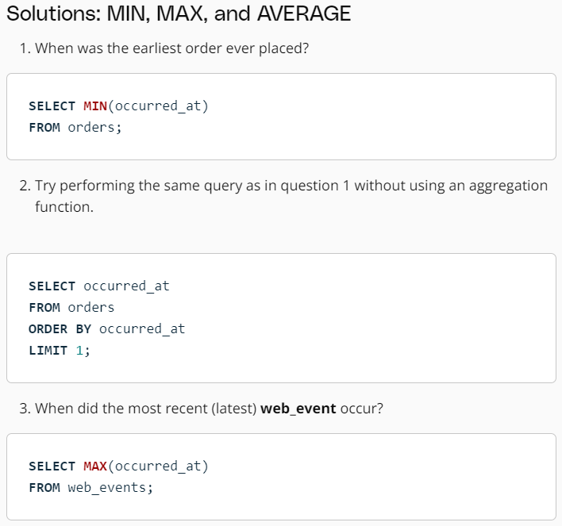

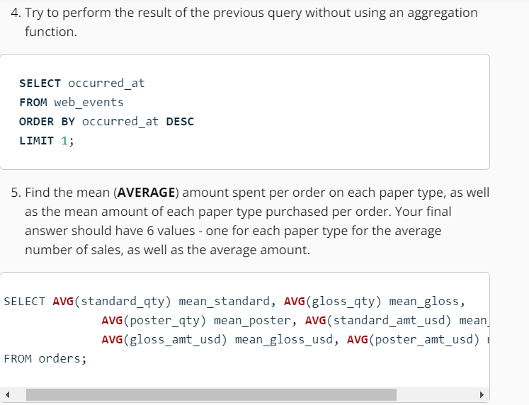

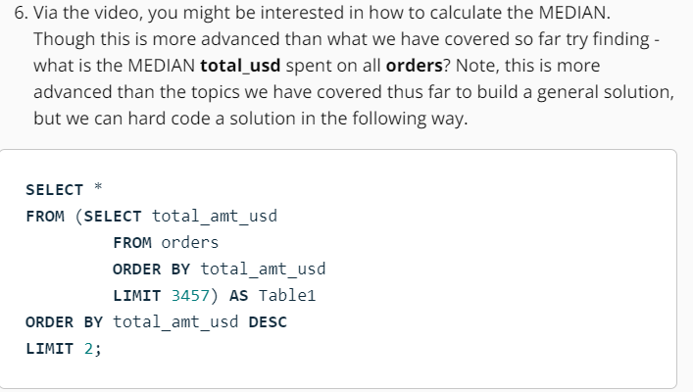

**GROUP BY**

**The key takeaways here:**

* GROUP BY can be used to aggregate data within subsets of the data. For example, grouping for different accounts, different regions, or different sales representatives.
* Any column in the SELECT statement that is not within an aggregator must be in the GROUP BY clause.
* The GROUP BY always goes between WHERE and ORDER BY.
* ORDER BY works like SORT in spreadsheet software.

**GROUP BY - Expert Tip**

Before we dive deeper into aggregations using GROUP BY statements, it is worth noting that SQL evaluates the aggregations before the LIMIT clause. If you don’t group by any columns, you’ll get a 1-row result—no problem there. If you group by a column with enough unique values that it exceeds the LIMIT number, the aggregates will be calculated, and then some rows will simply be omitted from the results.

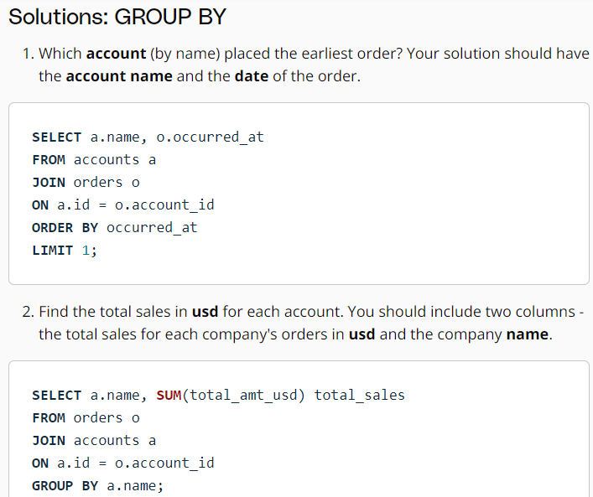

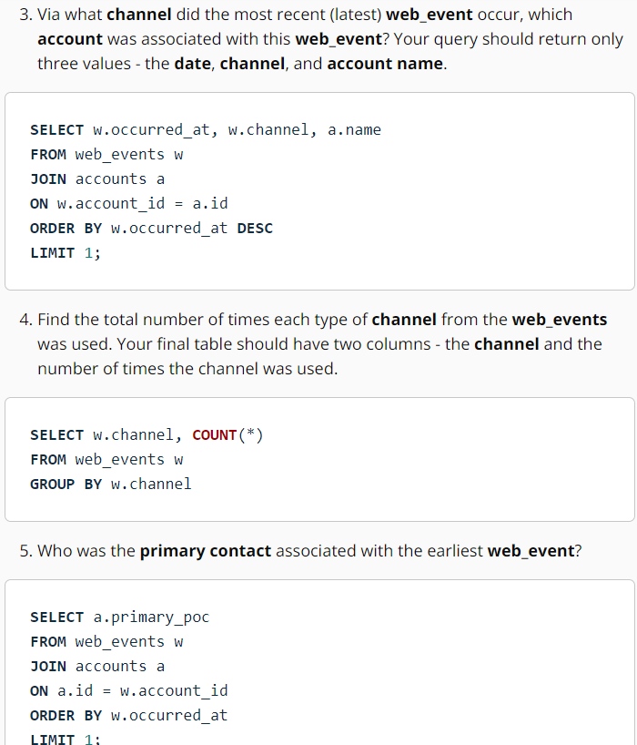

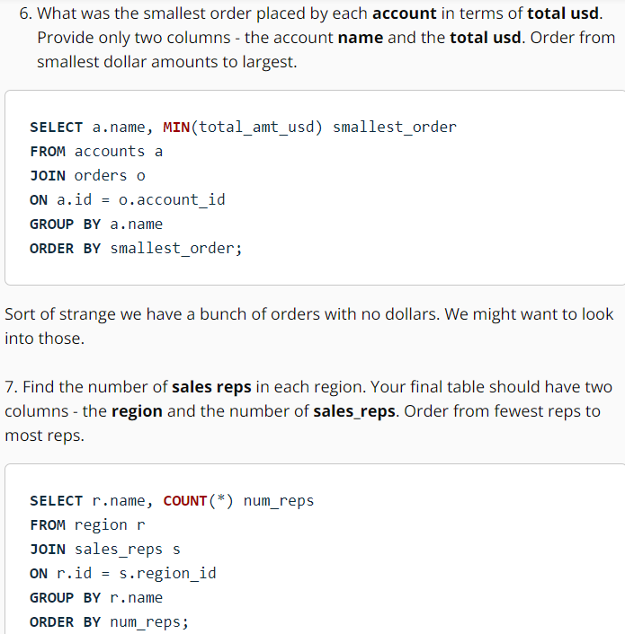

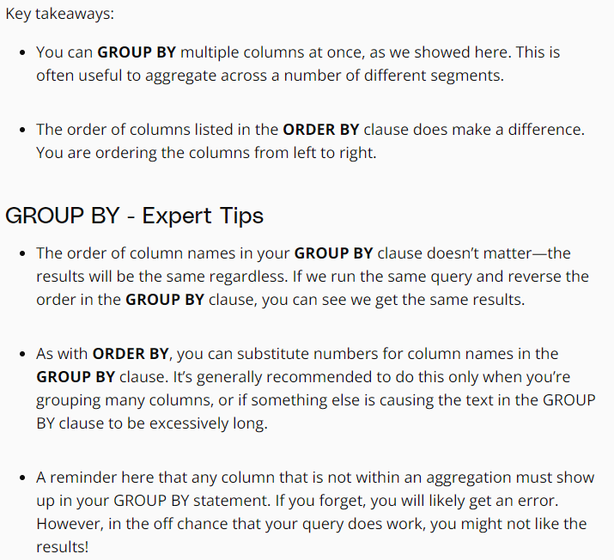

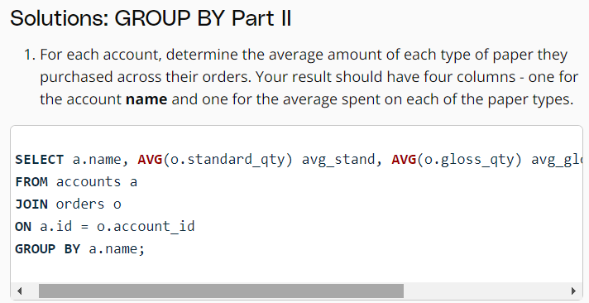

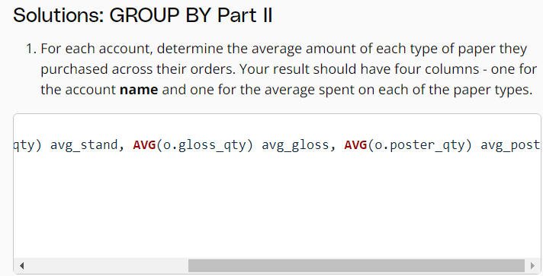

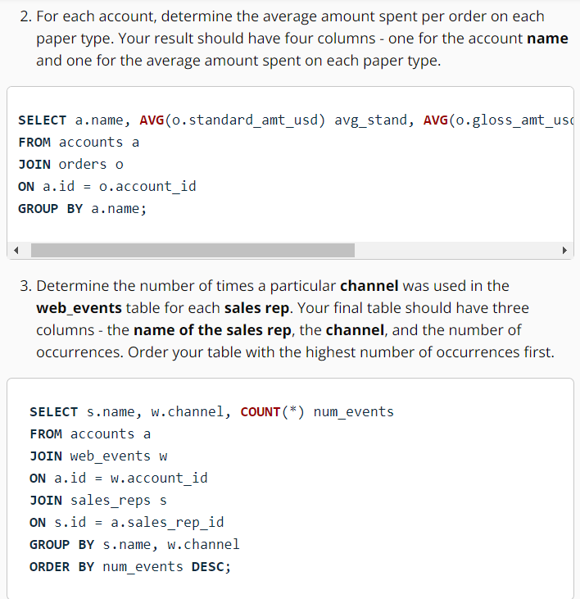

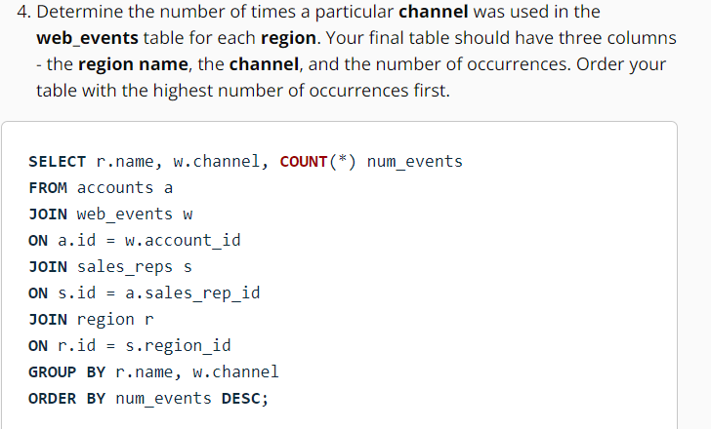

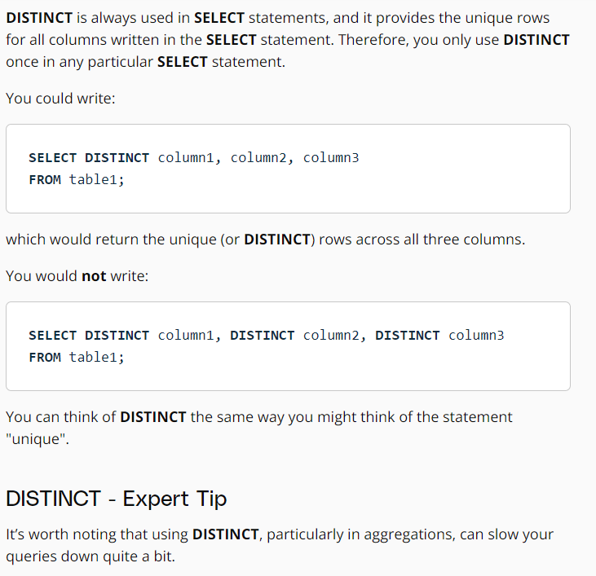

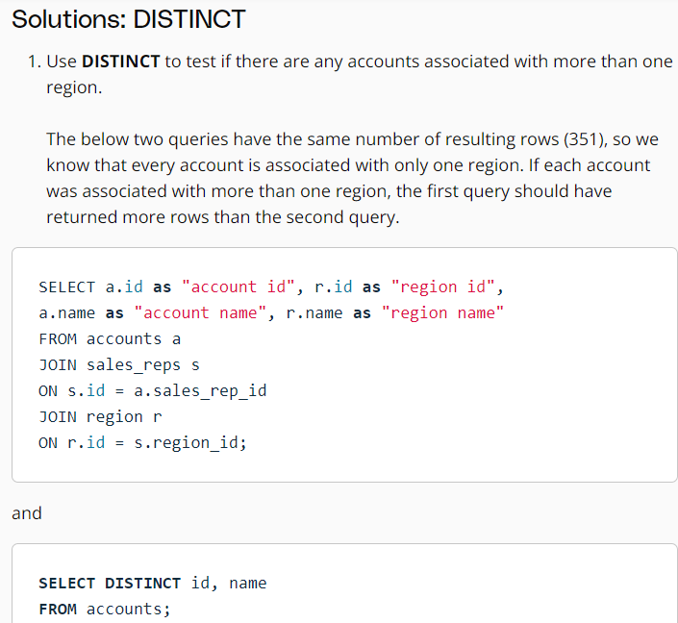

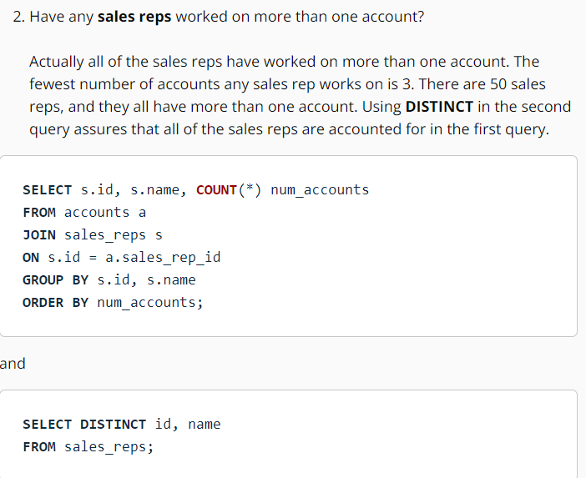

**HAVING:**

The HAVING function in SQL is used to filter the results of a query that has been aggregated using GROUP BY. It allows you to apply conditions to the aggregated data, similar to how the WHERE clause filters individual rows.

The key difference between the WHERE and HAVING clauses is that the WHERE clause filters individual rows before the aggregation, while the HAVING clause filters the aggregated results after the aggregation has taken place.

In other words, the HAVING clause is used to filter the groups created by the GROUP BY clause based on aggregate conditions. It allows you to specify conditions on the aggregated values, such as the sum, count, average, etc.

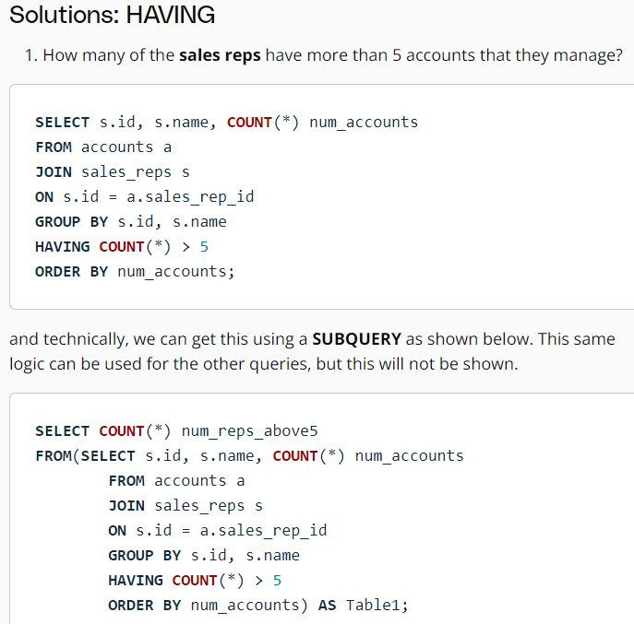

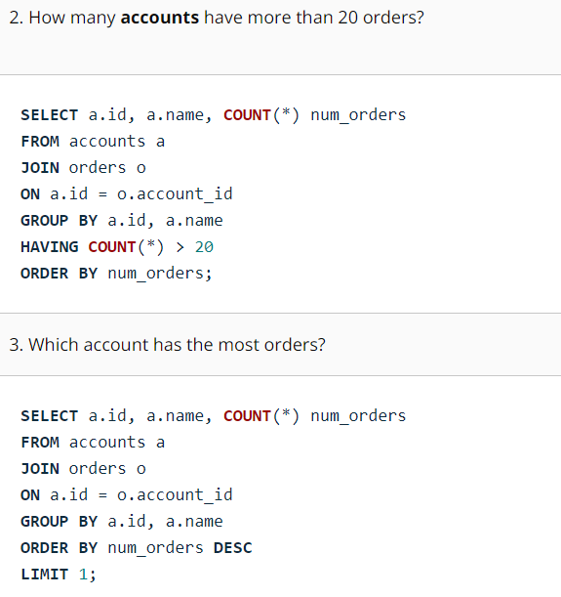

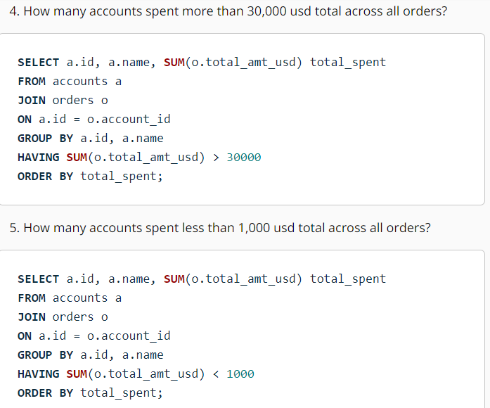

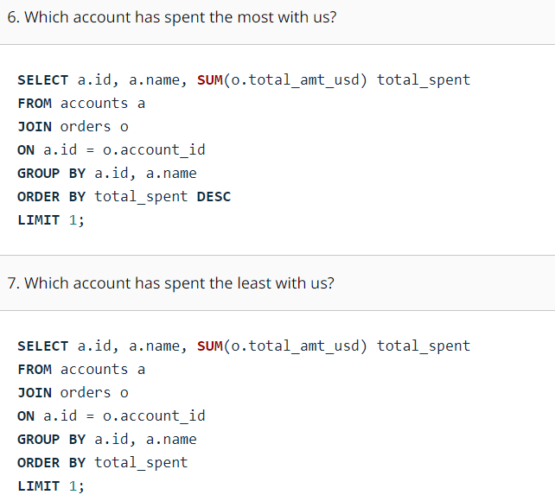

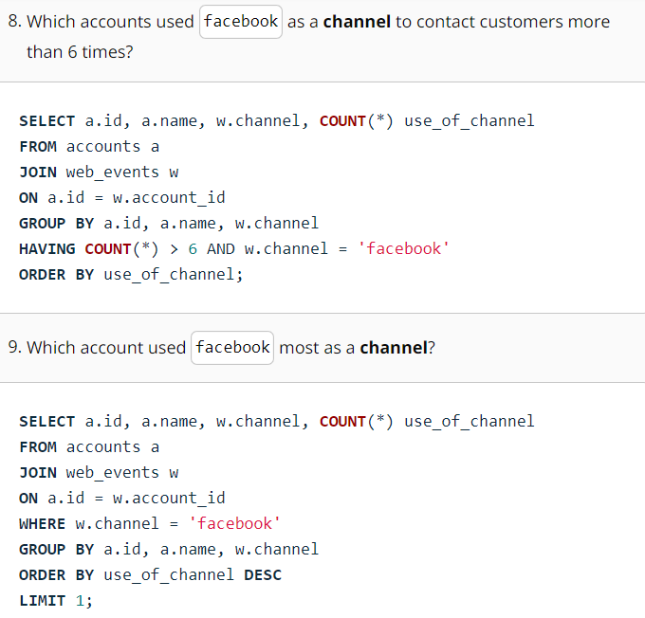

**DATE FUNCTION:**

The first function you are introduced to in working with dates is DATE_TRUNC.

DATE_TRUNC allows you to truncate your date to a particular part of your date-time column. Common trunctions are day, month, and year. Here (opens in a new tab) is a great blog post by Mode Analytics on the power of this function.

DATE_PART can be useful for pulling a specific portion of a date, but notice pulling month or day of the week (dow) means that you are no longer keeping the years in order. Rather you are grouping for certain components regardless of which year they belonged in.

For additional functions you can use with dates, check out the documentation here (opens in a new tab), but the DATE_TRUNC and DATE_PART functions definitely give you a great start!

You can reference the columns in your select statement in GROUP BY and ORDER BY clauses with numbers that follow the order they appear in the select statement. For example

SELECT standard_qty, COUNT(*)

FROM orders

GROUP BY 1 (this 1 refers to standard_qty since it is the first of the columns included in the select statement)

ORDER BY 1 (this 1 refers to standard_qty since it is the first of the columns included in the select statement)

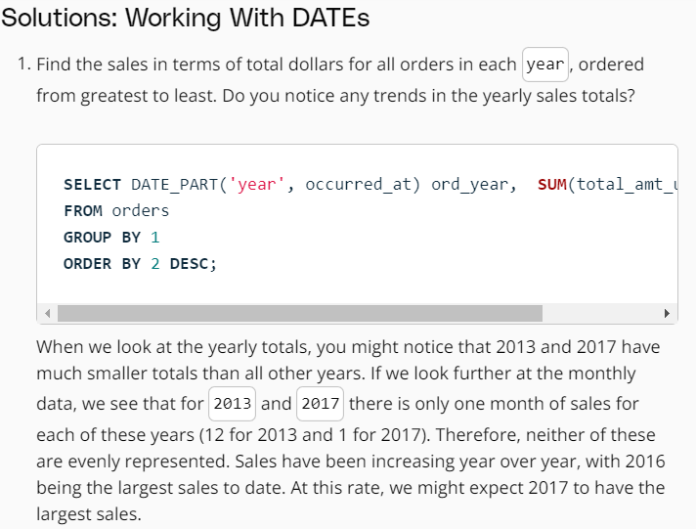

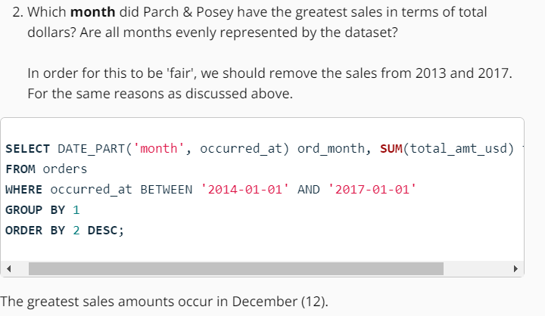

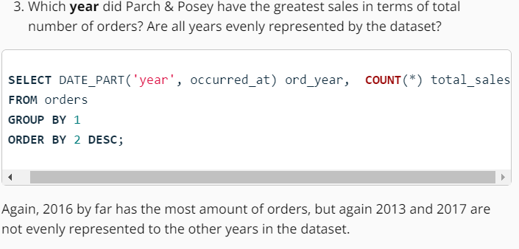

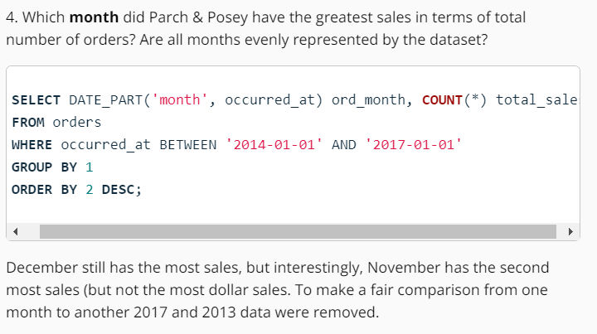

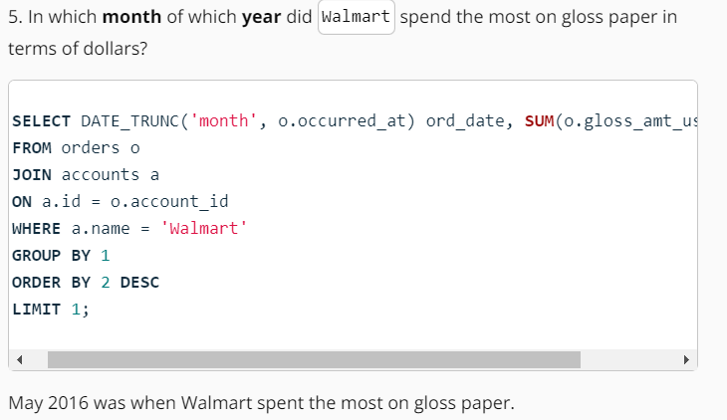

**CASE FUNCTION:**

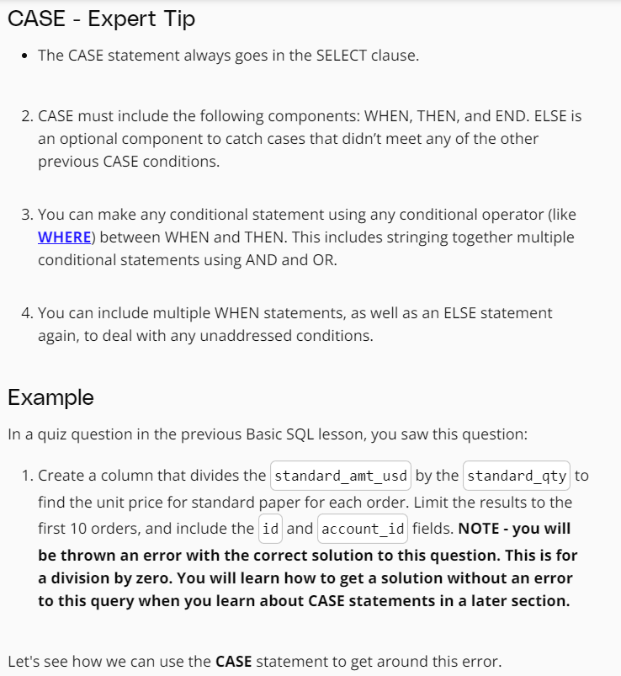

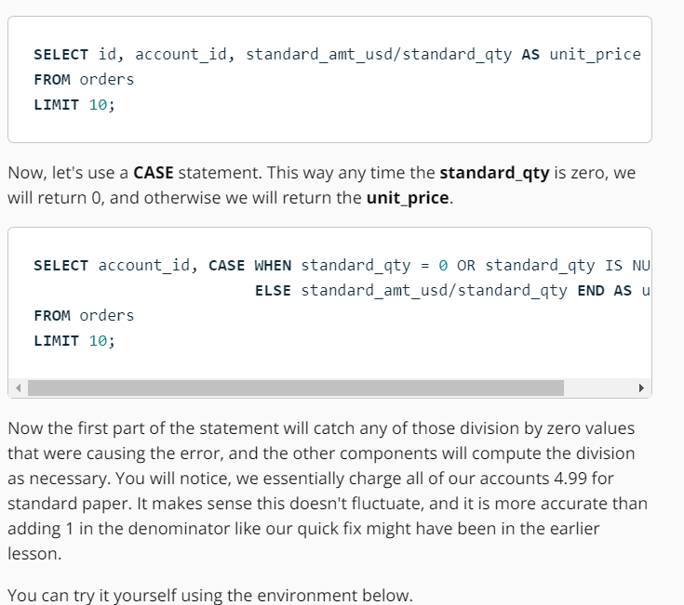

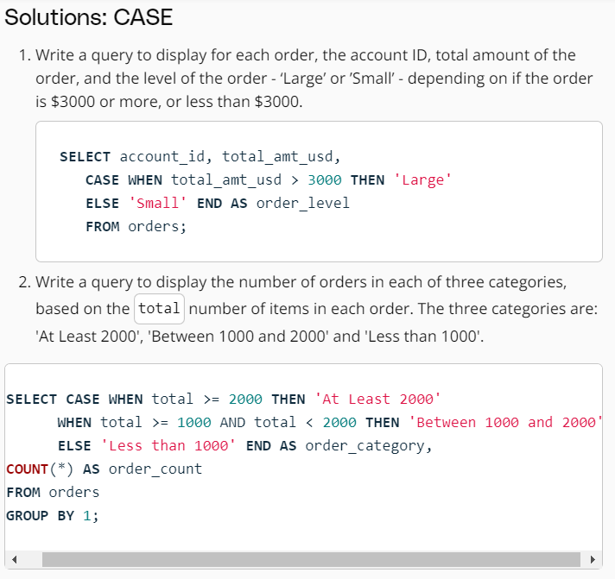

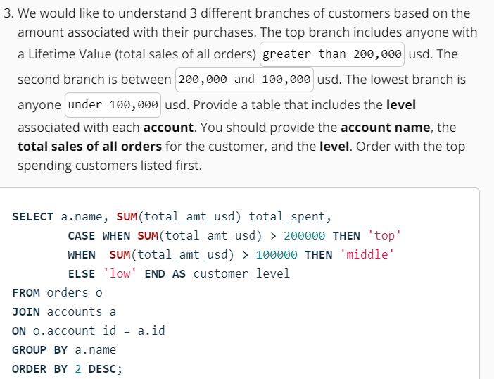

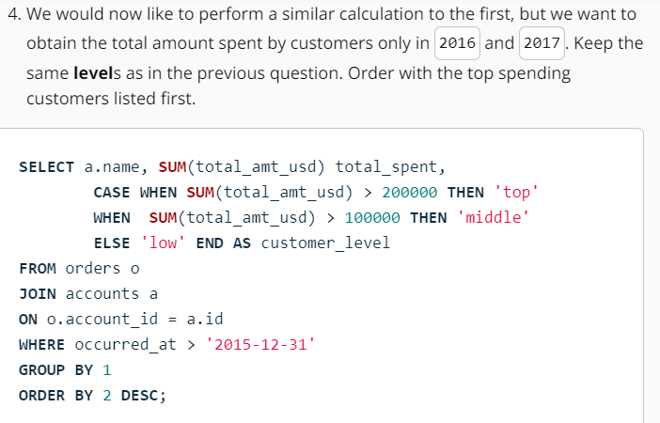

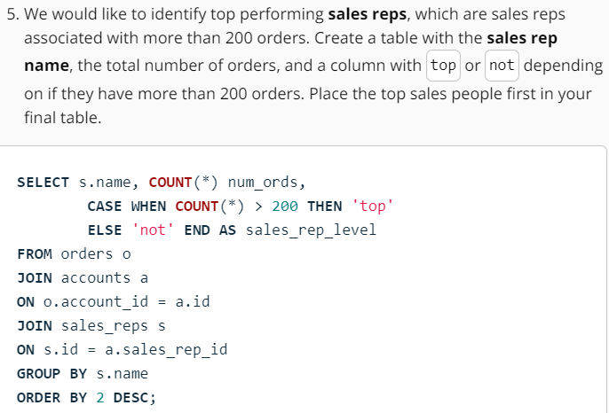

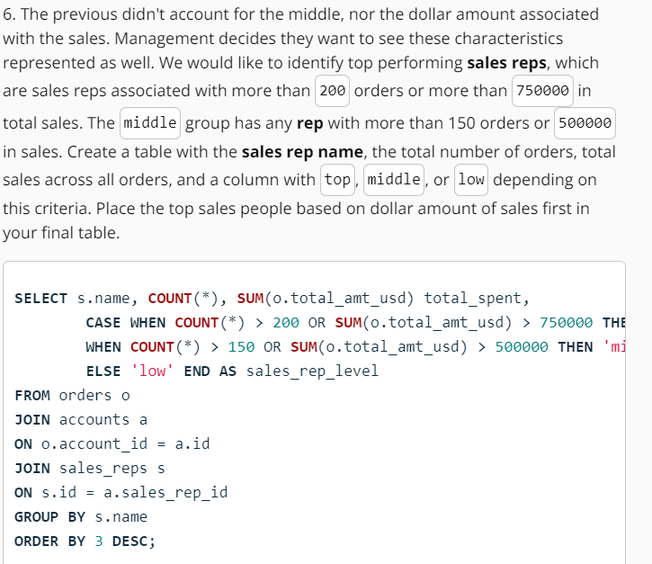

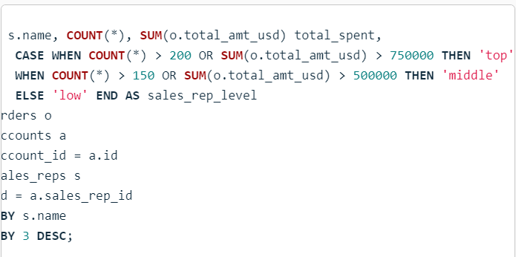

**SUBQUERIES:**

Subqueries in SQL are queries that are nested within another query. They allow you to use the results of one query as input for another query. Subqueries can be used in various parts of a SQL statement, such as the SELECT, FROM, WHERE, and HAVING clauses.

The main use of subqueries is to break down complex problems into smaller, more manageable parts. They enable you to perform operations on intermediate results and use those results to further refine your query.

**Here are a few common use cases for subqueries:**

**Filtering:** You can use a subquery in the WHERE clause to filter rows based on a condition that involves another table. For example, you can retrieve all customers who have made a purchase in the last month by using a subquery to check against the orders table.

**Comparison:** Subqueries can be used for comparisons, such as finding the maximum or minimum value from a subset of data. For instance, you can find the employees with the highest salary by comparing their salaries to the maximum salary obtained from a subquery.

**IN and NOT IN:** Subqueries can be used with the IN and NOT IN operators to check if a value exists or does not exist in a set of values returned by the subquery. This is useful when you want to filter rows based on a condition involving multiple values.

**EXISTS and NOT EXISTS:** These operators are used to check the existence or non-existence of rows returned by a subquery. They are often used in correlated subqueries, where the subquery refers to a column from the outer query.

These are just a few examples of how subqueries can be used in SQL. They provide a powerful way to perform complex operations and make your queries more flexible and efficient.

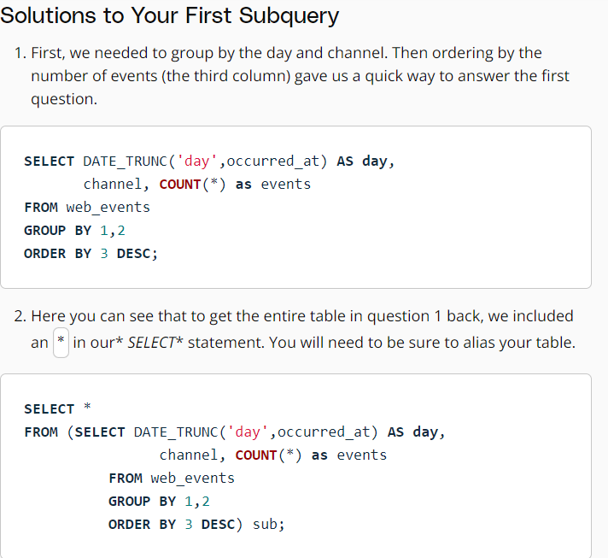

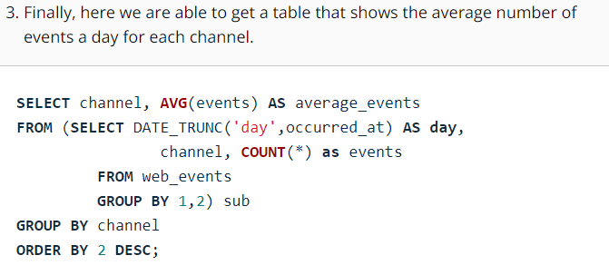

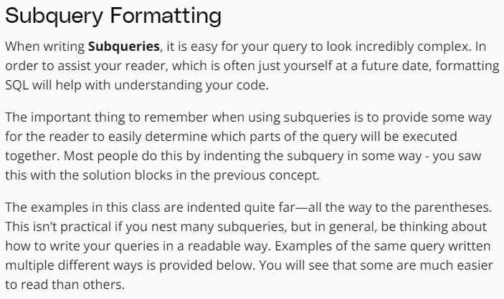

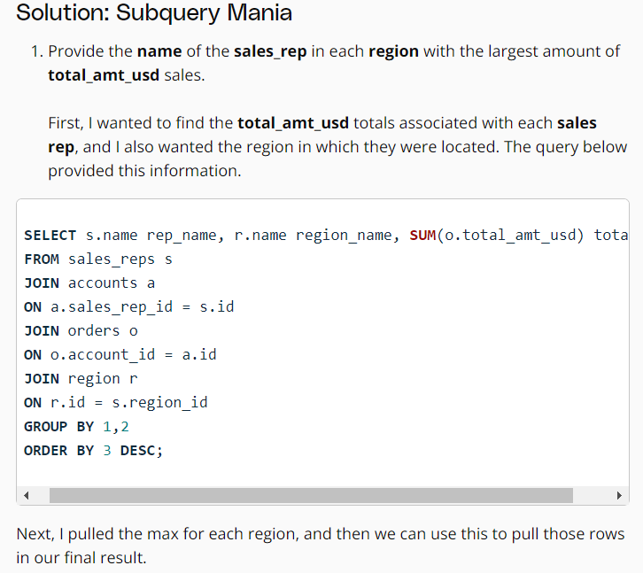

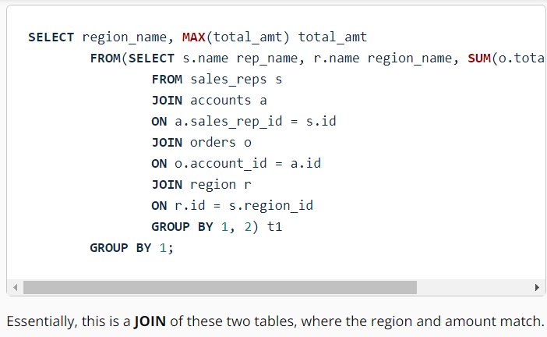

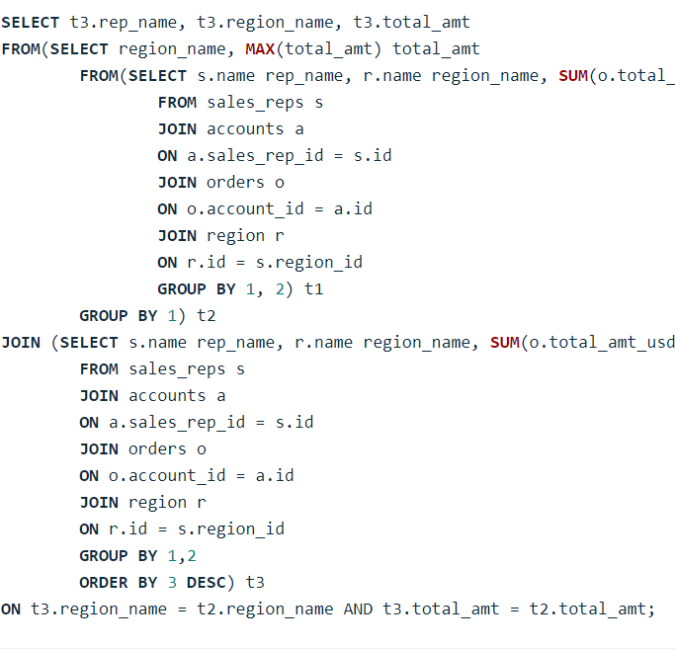

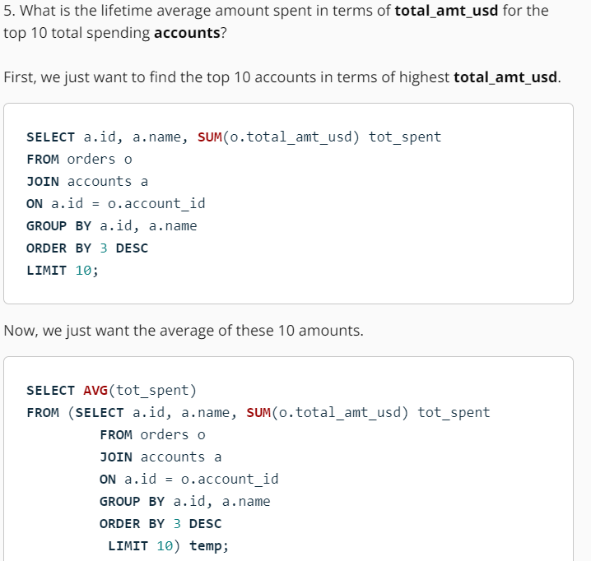

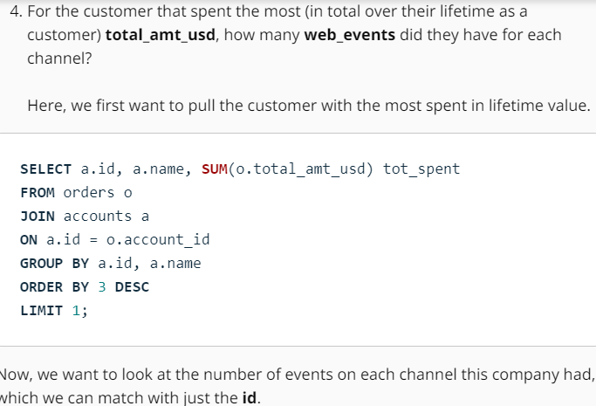

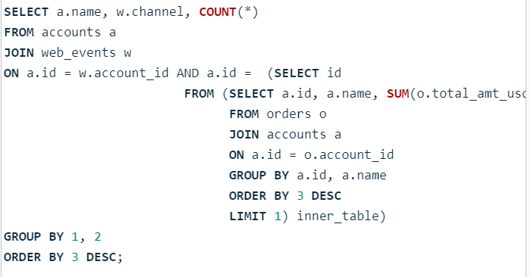

**WITH:**

The WITH statement is often called a Common Table Expression or CTE. Though these expressions serve the exact same purpose as subqueries, they are more common in practice, as they tend to be cleaner for a future reader to follow the logic.

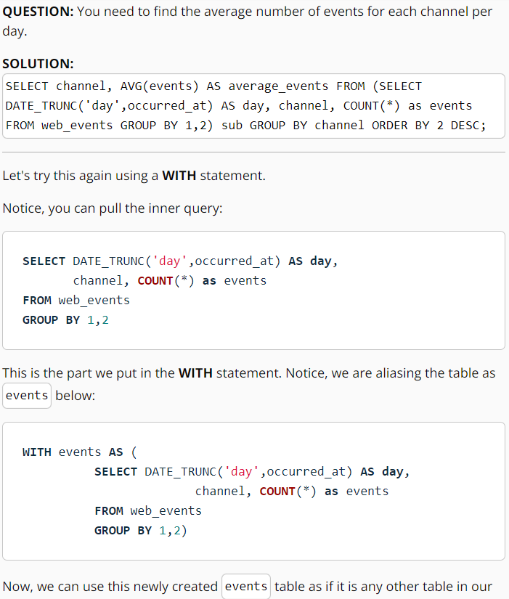

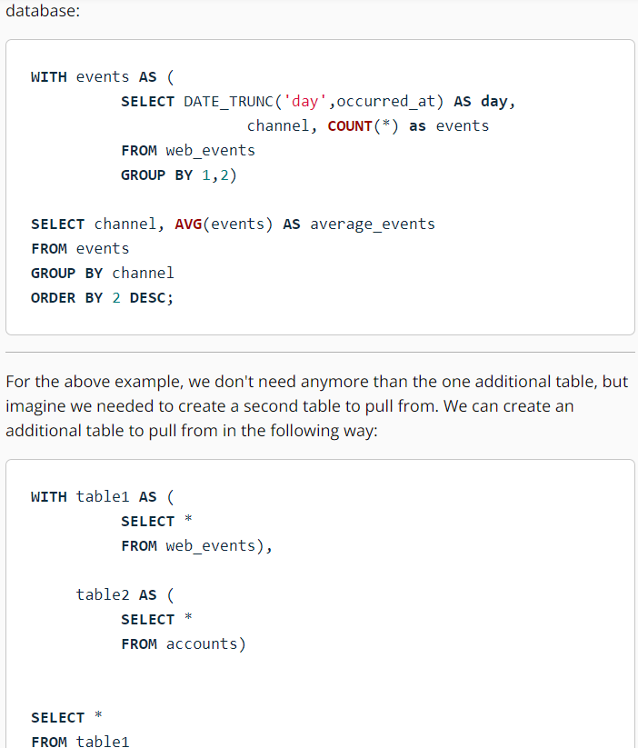

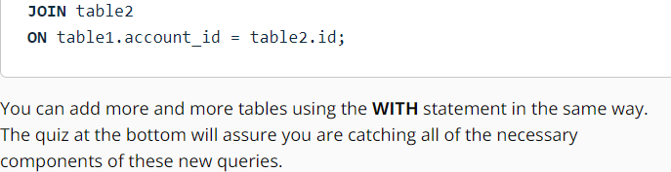

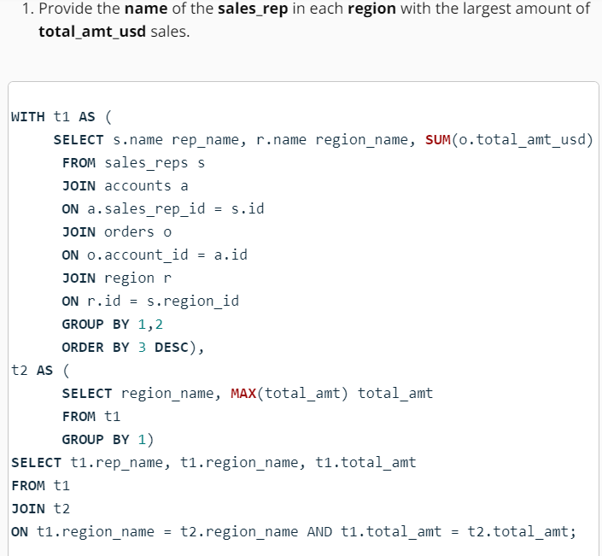

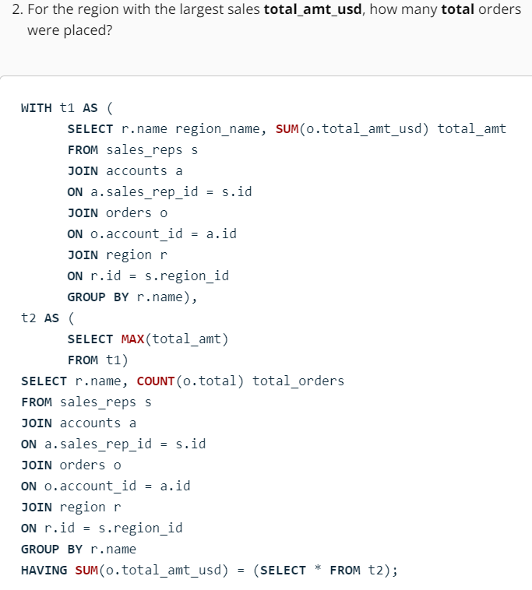

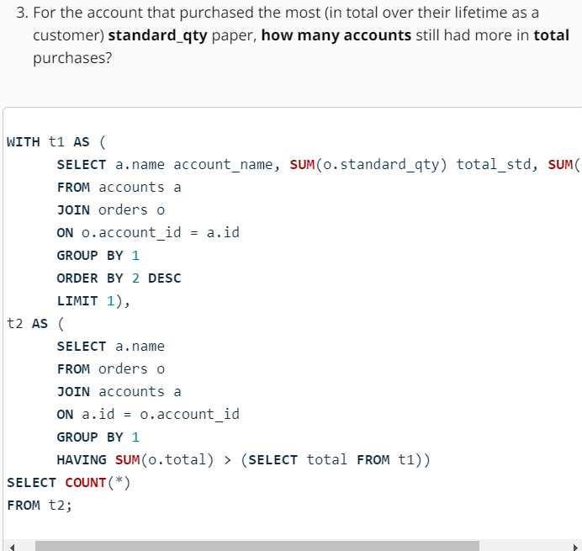

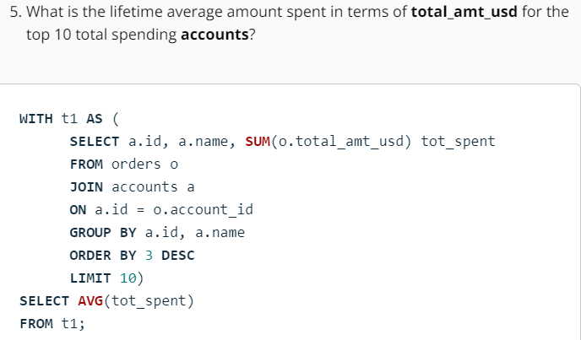

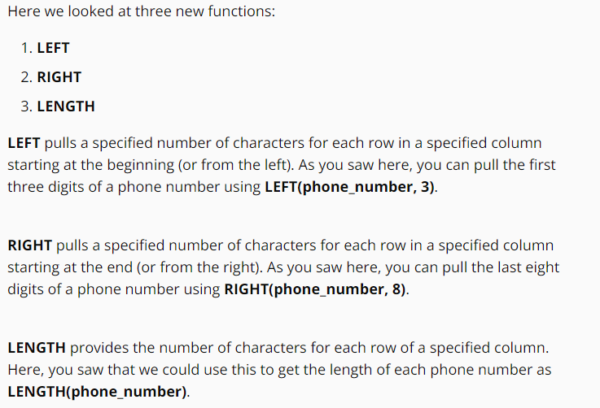

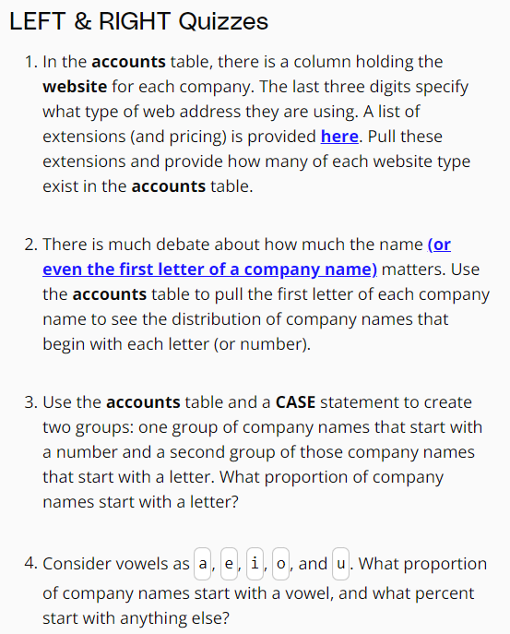

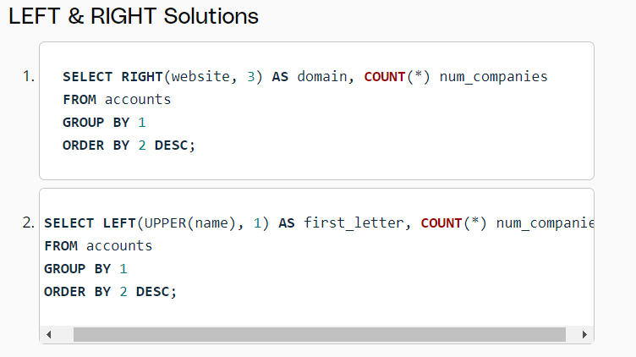

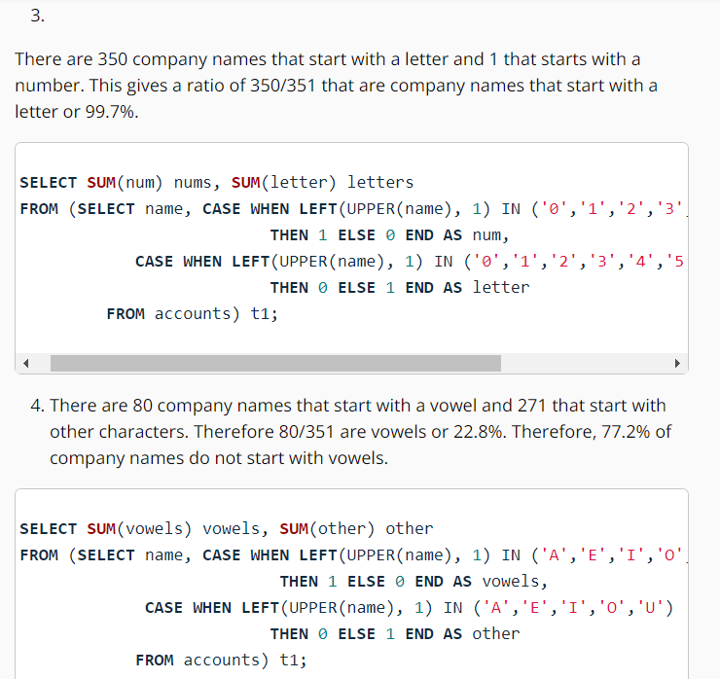

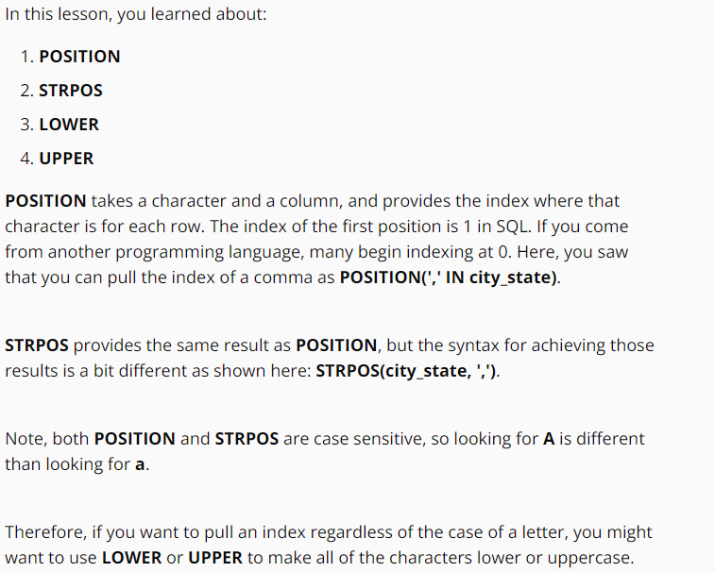

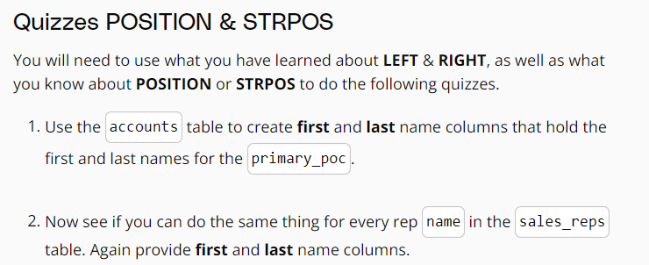

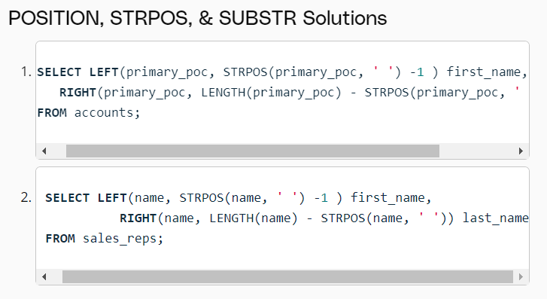

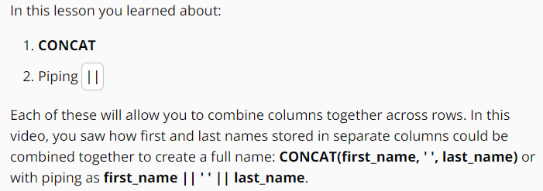

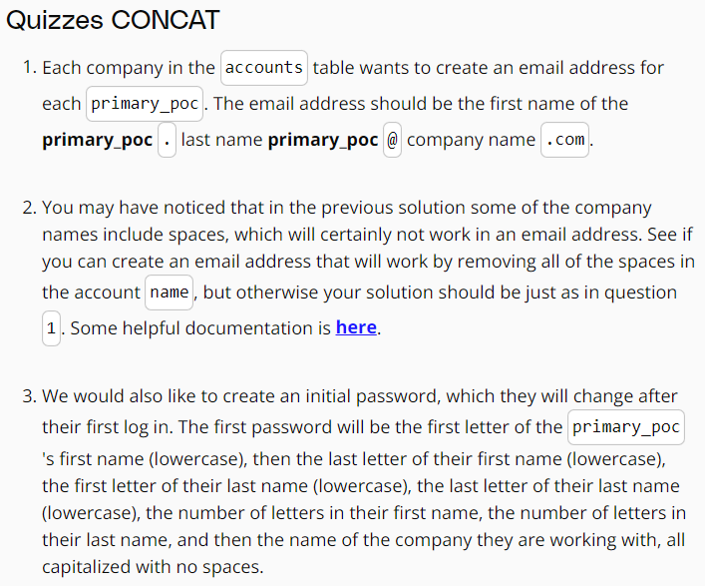

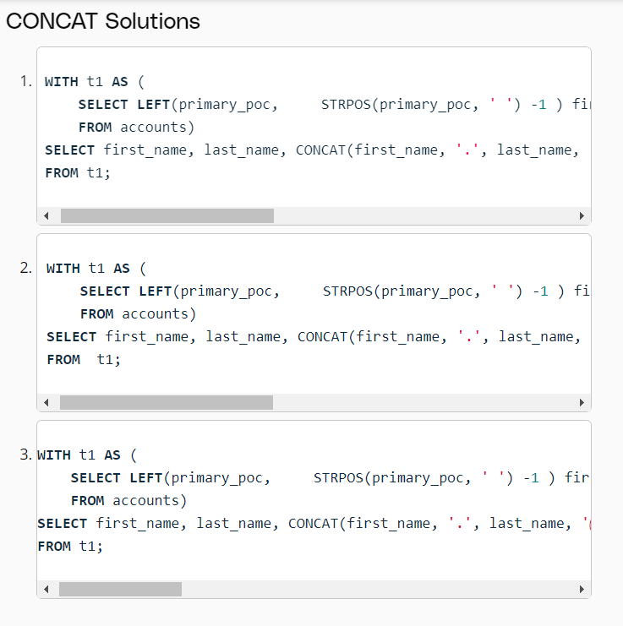

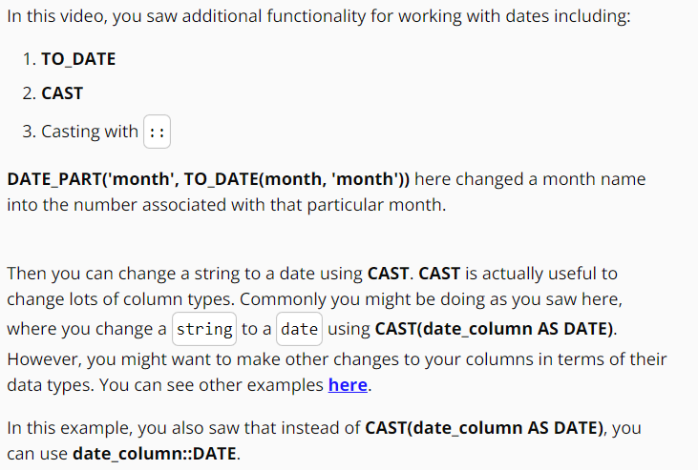

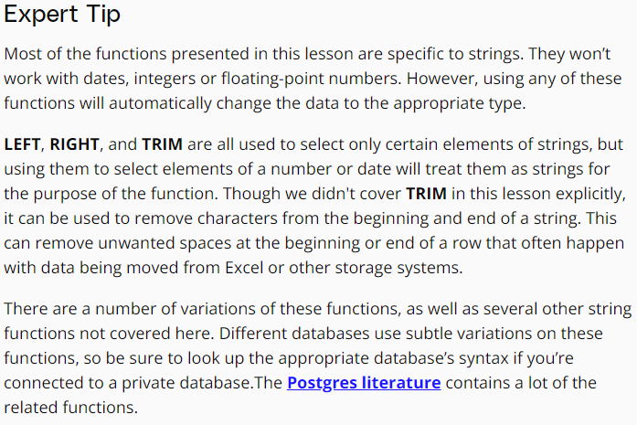

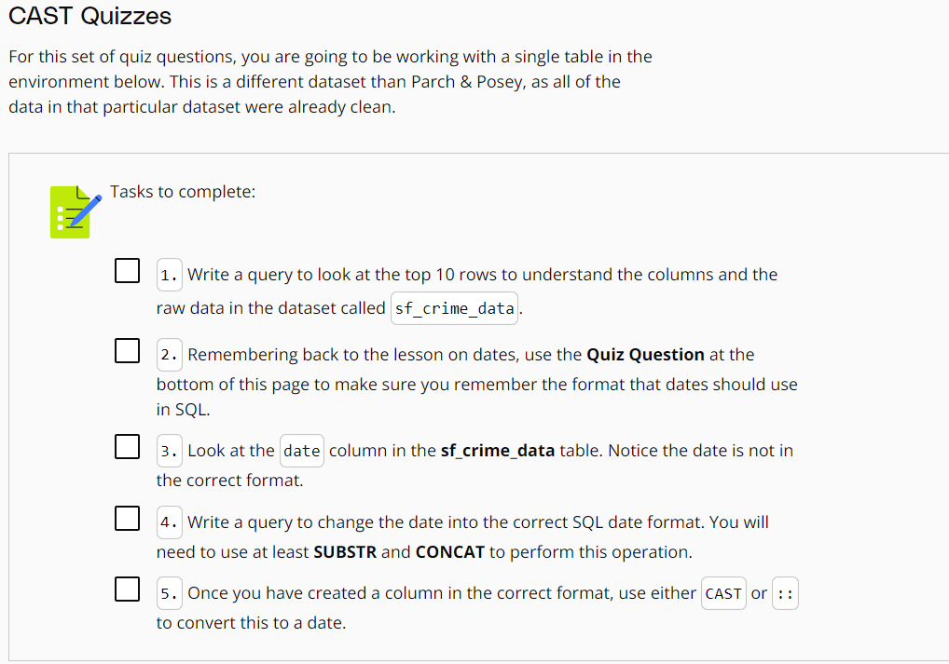

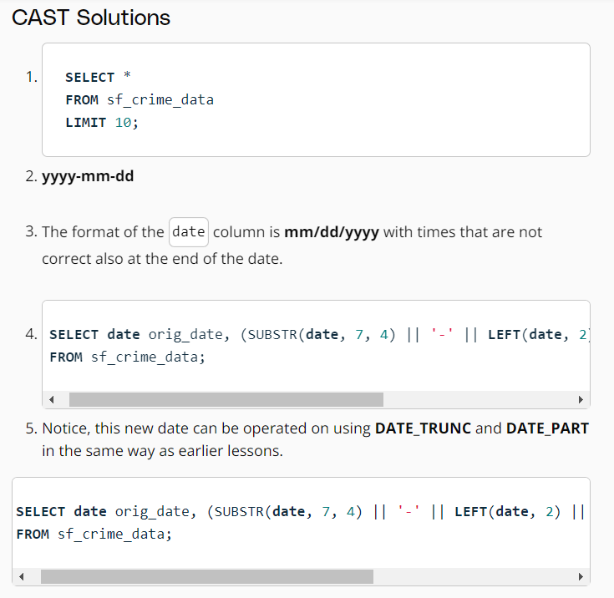

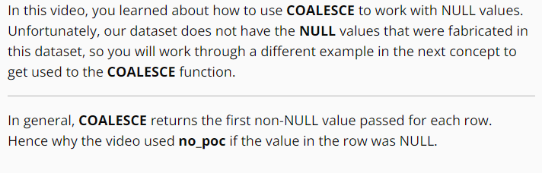

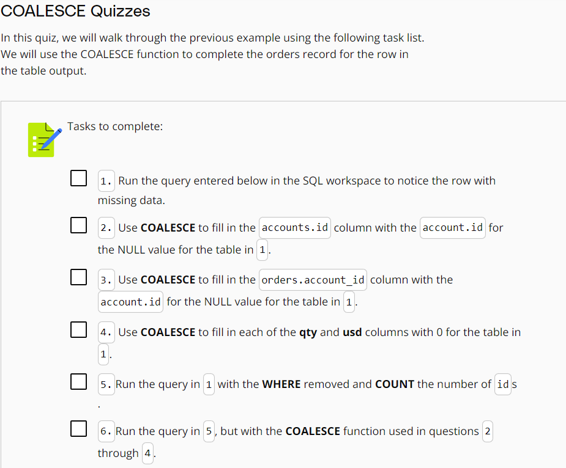

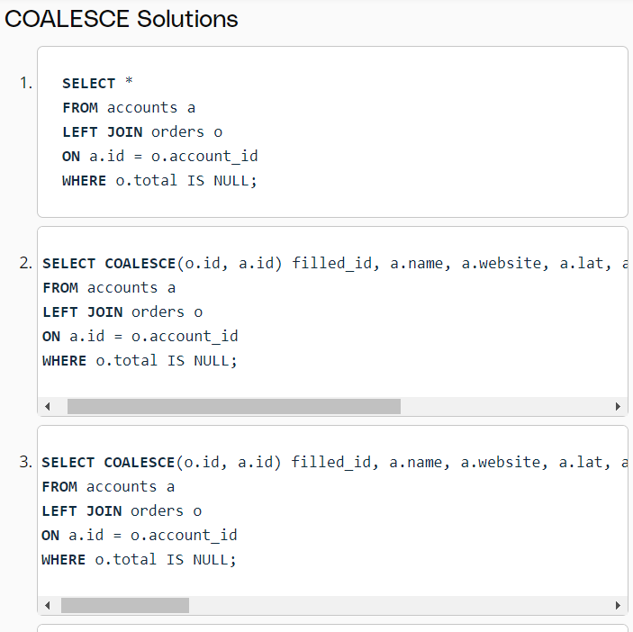

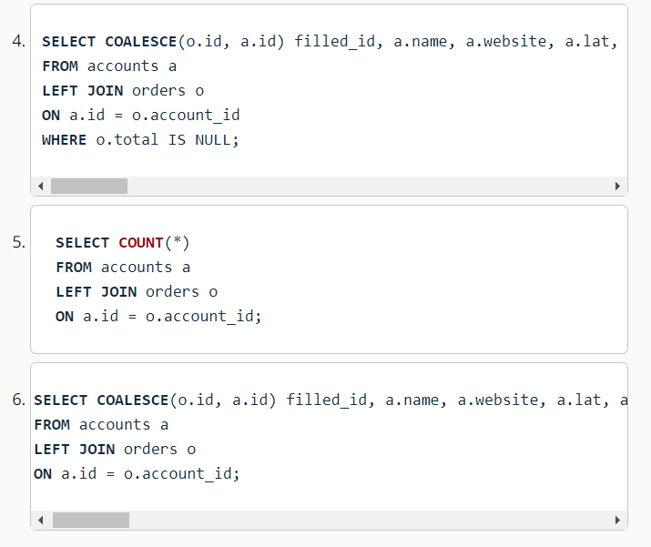

**WINDOWS FUNCTIONS:**

